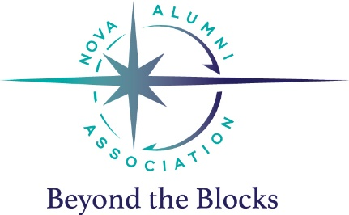
NOVA Alumni Association Scholarship

Purpose & General Guidelines
The NOVA Alumni Association has established a scholarship to be awarded annually. This scholarship is designed to recognize and reward outstanding dedication to the sport of swimming as well as contributions to NOVA, the applicant’s school, and the greater community.
One or more scholarships will be awarded to a graduating high school senior who is a current member in good standing and has been part of the competitive youth swim team at NOVA for a minimum of one year. Each scholarship is a one-time award and not renewable. The award will be paid directly to the recipient. For 2018, one $500 scholarship will be awarded.
Eligibility
An applicant must:
- Be a current member in good standing of NOVA’s competitive youth swim team
- Have been a NOVA swimmer for a minimum of one year
- Be a current high school senior
- Plan to attend a college or university starting in Summer or Fall of this year; you do not need to be swimming in college to apply
- Complete the full application
- Submit one sealed letter of recommendation
- Have a minimum 3.0 weighted Grade Point Average and submit an official copy of a high school transcript showing grades through 1st semester of his or her senior year
- Submit a Personal Statement
- If swimmer plans to continue swimming on a college/university athletic team, it is swimmer’s responsibility to verify eligibility to accept this award with the college or university.
Selection Process
The Selection Committee, comprised of a minimum of five members of the NOVA Alumni Association and/or NOVA employees (coaches and/or staff) will consider applications submitted by qualified seniors. The NOVA Coaching staff will also have input. The Selection Committee will determine the number of and amount of any scholarships awarded each year. All interested and qualified seniors are encouraged to apply.
Winner(s) will be selected based on the following criteria:
- Contributions to NOVA and the sport of swimming
- Contributions to the community
- Character qualities (including leadership, dedication, sportsmanship, integrity, and service)
- Personal statement
Please note, swimmers will not be evaluated solely on their swimming ability. The selection committee may interview the finalists to determine winner(s) if needed.
Application Components
The applicant must submit the following:
- The completed application
- One sealed letter of recommendation (approximately one-two pages, not from the applicant’s parent or NOVA coach)
  - The person completing the recommendation should be someone who can speak to the applicant’s involvement and success in their school community or the greater community (for example: high school principal, administrator, guidance counselor, coach, teacher or athletic director; religious leader; summer league coach or team representative; or community leader related to volunteering/service/etc.)
- An official copy of a high school transcript showing grades through 1st semester of his or her senior year
- The Personal Statement answering the question “What is your story, and how does NOVA fit into that story?” (no more than 750 words)
To Submit
- Please download the application/Personal Statement, fill it out, save it, and submit it via email to novaalumni@novaswim.org.
- Deliver your transcript and sealed recommendation to NOVA, Attn: Alumni Scholarship, 12207 Gayton Road, Richmond, VA 23238
- The 2018 deadline for submitting all materials for consideration is 5 p.m. Friday, May 18, 2018.

