To Drink or not to Drink on a Recruiting Trip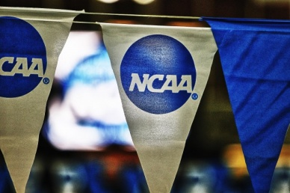 Swim News: Rick Paine reports on the do’s and don’t's during a college recruiting trip. Contributor, Rick Paine, is a friend and an expert on the college recruiting process.
Drinking on college campuses has always been there and unfortunately probably always will be. Athletes are not immune the allure of alcohol even though it is counterproductive to all of the training they do. Recruiting trips and parties seem to go hand in hand and many times drinking is involved. If you are fortunate enough to be invited on a recruiting trip, you should prepare yourself to deal with this issue.
Here is a typical recruiting trip. You fly in on a Friday and one of the coaches picks you up at the airport. You go to lunch with the coaches and your student host. You meet with the academic counselors and maybe attend a class or two with a student-athlete. You go and watch practice then hang out with the team at one of the coaches’ homes. You go back to the dorm room with your host and maybe watch a movie and talk.
Saturday morning you meet the swim team for breakfast then meet with one of the coaches while the team is training. You then head out with the team for a day of fun and probably go to a football game. Later that night the team may host a party for you and the other recruits.
Everyone is making you feel welcome and you are excited to feel like you are part of the team. You notice that some of the team is drinking (hopefully only some of the team) and one of the upperclassmen brings you a beer. The upperclassman tells you how much everyone likes you and shoves a beer in your face telling you it is OK because all of the recruits drink on their trip.
I am not going to sit here and tell you of all of the reasons not to drink, but I am going to remind you about two of them. It is illegal and you could be arrested or given a citation. Wouldn’t that be a fun conversation to have with your parents and your coach when you get back home?
You can be assured that the coaches will find out. Don’t let anyone tell you that no one will know. With today’s cell phone cameras and social media outlets it is only a matter of time before your mug is plastered all over facebook with a beer in your hand and you are labeled as a partier.
Now you are back at home waiting for the coaches to call you, but the phone doesn’t ring. The coaches have asked some of the team about you and perhaps have seen the photo of you holding a beer. That one moment has labeled you as a party animal and I guarantee you that coaches don’t recruit party animals.
So what do you do without coming across as uncool?
- As soon as you get to the party get a lemonade or a soda so that you have something in your hand.
- Don’t stand in the middle of the room like a statue. Interact with the team, especially with the non-drinkers.
- If someone offers you a drink politely decline and let them know that you already have something to drink.
- If they persist, let them know that you are focused on your training for this season and that your coach would kick your butt if you had a drink.
If you feel pressured to drink in order to fit in with the team, then you should re-evaluate if the team is right for you.
Under no circumstances should you drink on a recruiting trip!!!!!!!!!!!!!

