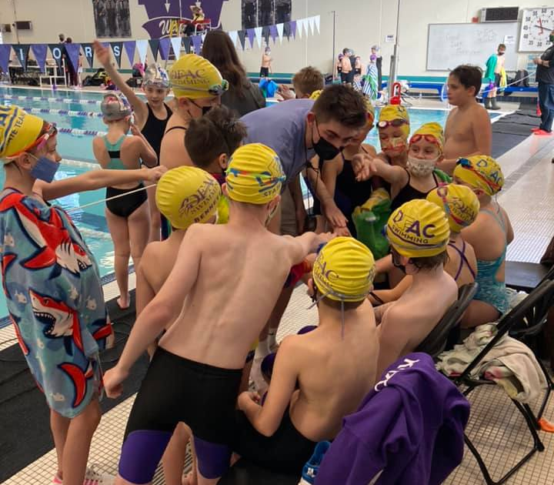
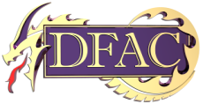

DFAC swimming is a parent-run, nonprofit organization that has served the needs of hundreds of area swimmers for over 30 years. As a club governed by USA Swimming, it is our mission to help area youth develop swimming skills and inspire and nurture each individual so that they can reach their maximum potential. YOU CAN HELP by becoming a corporate sponsor. Funds raised through our sponsorship program will help cover meet hosting expenses, coaching education, and training, as well as travel expenses incurred to attend out of town meets. Without the continued support of our local area merchants and civic-minded community backers, our program would not be possible.
Help support us in promoting healthy, active living, and join in the sponsorship of DFAC. It is through your support that we can continue to make this an affordable opportunity for many of our youth. Cash and in-kind product donations are needed to make our club a success. Companies donating product for various events will receive the category of sponsorship that is closest to the estimated amount of the donation. All donations are tax deductible.
Thank you for your support, and please consider becoming a sponsor!

Levels of Sponsorship
- Blue Ribbon
- Red Ribbon
- White Ribbon
- Yellow Ribbon

If interested in learning more about DFAC Sponsorship Opportunities, please reach out to DFAC Vice President @
vice-president@dfacswimming.org

DFAC is a qualified 501(c)3 registered with the State of Wisconsin.
SPONSORSHIP
OPPORTUNITIES
Deforest Aquatic Club

DFAC SPONSORSHIP PACKAGES
Yellow Ribbon Sponsor $250 donation
- Company Name listed on the DFAC website homepage with a hotlink to your website
- Company Name listed in all home meet heat sheets (~4/year)

White Ribbon Sponsor $500 donation
- Company name listed on the DFAC website homepage with a hotlink to your website
- Company name listed in all home meet heat sheets (~4/year)
- Company name announced during home meets (~ 4 per year)

Red Ribbon Sponsor $1000 donation
- Company name listed on the DFAC website homepage with a hotlink to your website
- Company name and logo (½ page advertisement) in all home meet heat sheets (~4/year)
- Company name announced during home meets (~ 4 per year)
- Company name and logo displayed on corporate sponsorship banner at all home meets

Blue Ribbon Sponsor $2000 donation
- Company name listed on the DFAC website homepage with a hotlink to your website
- Company name and logo (full page advertisement) in all home meet heat sheets (~4/year)
- Company name announced during home meets (~ 4 per year)
- Company name and logo displayed on corporate sponsorship banner at all home meets
- Company name and logo on DFAC team shirts worn by team members and coaches
- Promotional flyer/business card/giveaway in annual fundraiser giveaway bag (1x per year)

DFAC Swimming Corporate Sponsorship Program
Company Name: _________________________________________________________________________________________
Contact: ___________________________________ Title: _____________________ Phone number: ___________________
Email: _________________________________________________________________________________________________________
Sponsorship Level (circle): ☐ Yellow ☐ White ☐ Red ☐ Blue
Please complete the information above and mail with payment to:
DFAC Swimming Sponsorship
PO BOX 215
Deforest WI 53532
Email company name and logo to Vice-President@dfacswimming.org

