2018

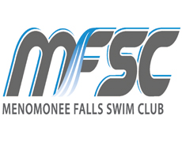

Menomonee Falls Swim Club
Spring Swim Clinic

Improve your swimming technique and endurance with Age Group Coach Matt Kopp and Head Coach Scott Mueller. If you are looking to improve your technique, build your endurance, swim and have fun with a small group on a regular basis then this is the program for you!

Where: Menomonee Falls North Middle School Pool

When: April 3rd – June 7th (Tues/Thurs nights)

Who: Beginning and Intermediate Swimmers looking to better their swimming ability in all four strokes, starts, turns and increase their knowledge of the sport. Swimmers must be able to complete one length of front crawl/freestyle or backstroke in order to participate. Ages 9-13

Details: The group will meet every Tues/Thurs 4:00-5:00pm.

Cost: $220 for 20, 1-hour sessions. There will only be 24 swimmers accepted into the group, at a first come first serve basis.

For more information about the program please contact Head Coach Scott Mueller, (262)-347-7107 or email at Coachscottmueller@gmail.com. You can register online on our website www.mfswim.org click the registration tab in the upper right hand corner of the page.

