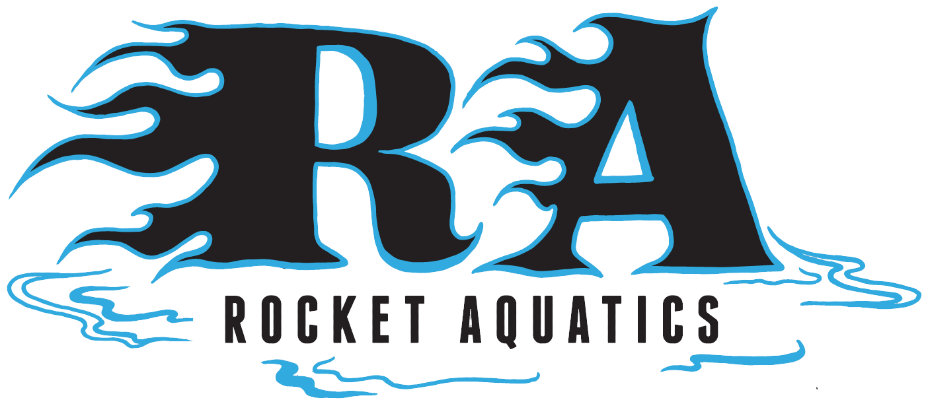

Rocket Aquatics
Summer Swim Clinic

Improve your swimming technique with Head Coach Scott Mueller and Rocket Aquatics Staff. Scott was a 2012 National Junior Team Coach, has coached swimmers to qualify for Olympic Trials, National and Junior National Championships and numerous individual state champions.

This is a Program for Beginning and Intermediate Swimmers ages 9-14 looking to better their swimming ability in all four strokes, starts, turns and increase their knowledge of the sport. Swimmers must be able to complete one length of front crawl/freestyle or backstroke in order to participate.

Location: Menomonee Falls High School Pool
Mondays, Tuesdays, and Thursdays
June 14 – July 12 (No practice July 5)
6:30-7:30 p.m.
Cost: $150 for a total of 12, 1-hour sessions
Clinic will be capped at 40 swimmers

*If you are interested in our Pre-Competitive learn to swim clinic for 4-8-year-olds that are too novice for the clinic, please inquire. They are offered at the same time. Pricing and times vary for our Pre-Competitive group.

For more information, please go to our website www.Rocketaquatics.org click the “Swim Clinic” tab on the right side of the page to access the online registration/info landing page. Any other questions contact Coach Scott Mueller, coachscottmueller@gmail.com or (262) 347-7107.

