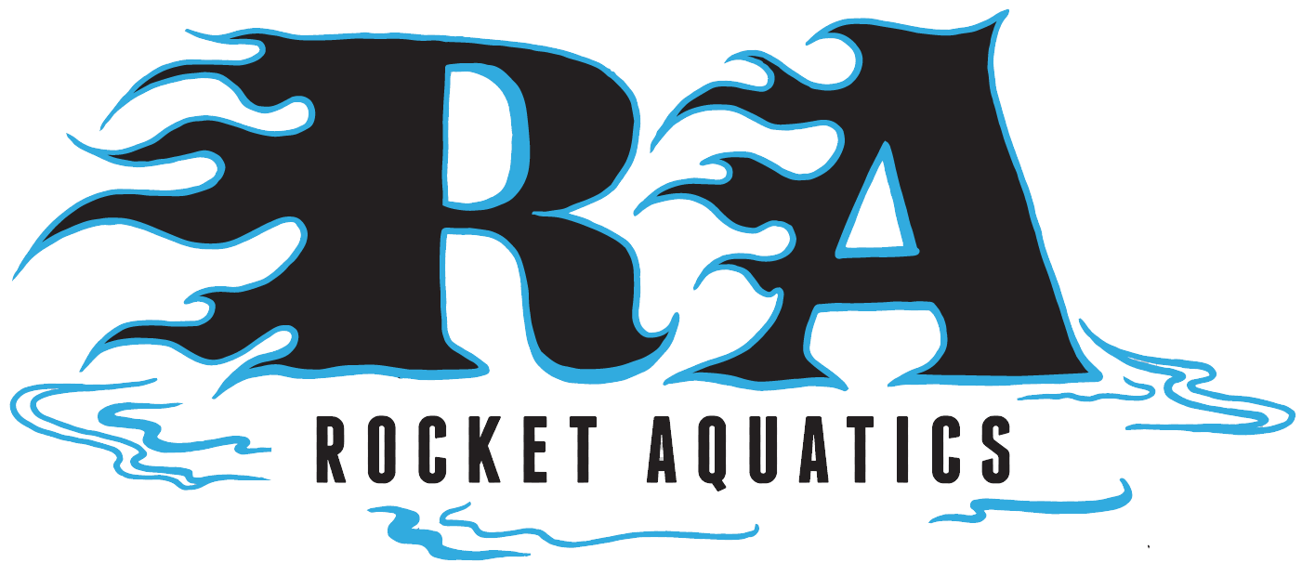

High School Swimming
Spring Training Program

Improve your swimming technique and endurance with Coaches Scott Mueller, Lori Bruss and Matt Kopp. If you are looking to improve your technique, stay competitive, in shape and swim with a small group on a regular basis then this is the program for you.

Where: Germantown High School Pool

When: April 11th – June 8th (Mon/Wed nights)

Who: Swimmers looking to better their swimming ability in all four strokes, starts, turns and increase their endurance. Swimmers must be able to complete 20 lengths of front crawl/freestyle or backstroke and swim all four strokes to participate. Ages 12-18. This program is geared towards preparation for the H.S. swim team, staying in shape and is a great segway to joining swim club!

Details: The group will meet every Mon/Wed 5:30-7:00pm. Workouts and Technical instruction provided every practice. No practice May 30.

Cost: $265 for 17, 1-hour and 30min sessions. There will only be 20 swimmers accepted into the group, at a first come first serve basis.

For more information about the program please contact Coach Scott Mueller, (262)-347-7107 or email at coachscottmueller@gmail.com. You can register online on our website www.rocketaquatics.org click the “Swim Clinics” tab on the upper right-hand corner of the page.

