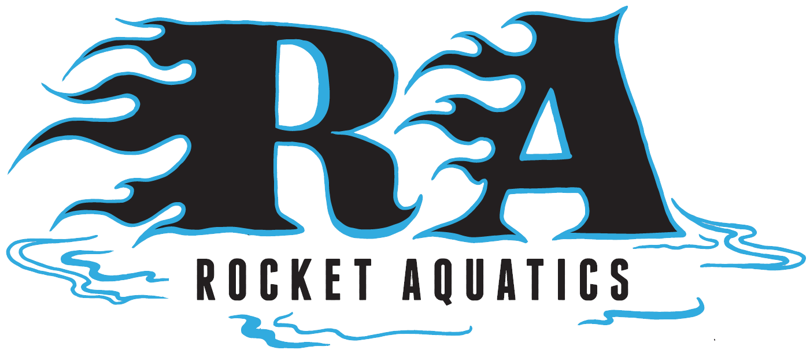

High School Training Program

Improve your swimming technique and endurance with Rocket Aquatics Coaches Scott Mueller and Lori Bruss. If you are looking to improve your technique, stay in shape and swim with a small group and get ready for the High School Swim Team then this is the program for you.

Where: Germantown High School Pool

When: June 13th – July 25th (Monday/Wednesday/Friday) There will be no practice July 4th or July 8th.

Who: Swimmers looking to better their swimming ability in all four strokes, starts, turns and increase their endurance. Swimmers must be able to complete 20 lengths of front crawl/freestyle or backstroke and swim all four strokes to participate. Ages 12-18.

Details: The group will meet every Mon/Wed/Fri 8:30-10:00am.

Cost: $260 for 17, 1-hour and 30min sessions. There will only be 20 swimmers accepted into the group, at a first come first serve basis.

For more information about the program please contact Head Coach Scott Mueller, (262)-347-7107 or email at Coachscottmueller@gmail.com. You can register online on our website www.RocketAquatics.org click the Swim Clinics tab on the right-hand side of the page. The Info/Registration can be found at the bottom of the swim clinics landing page.

