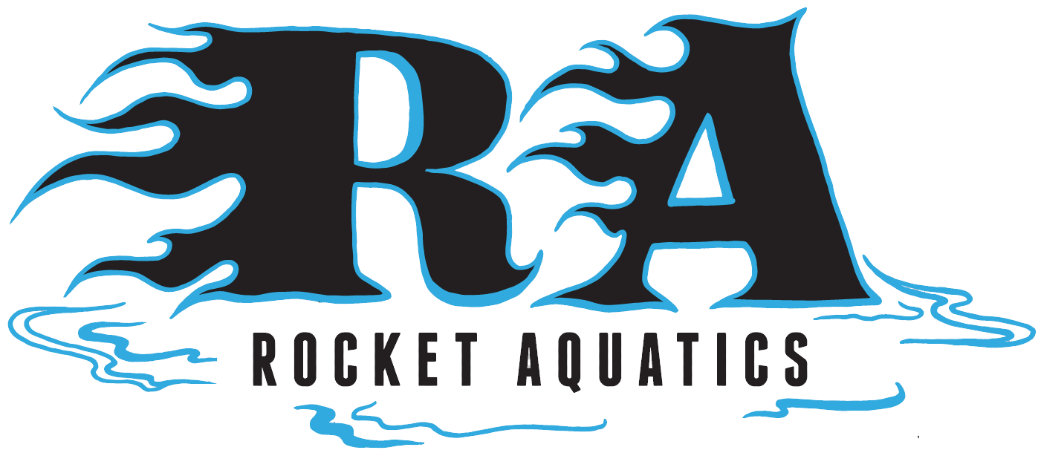

Rocket Aquatics
Summer Swim Clinic Session 2

Swimmers that participated in our first summer swim clinic that are looking to continue to improve, progress and have fun are invited to our second summer session.

Location: Menomonee Falls High School Pool
Tuesdays and Thursdays
July 12 – Aug 11 (No practice July 28th)
6:30-7:30 p.m.
Cost: $125 for a total of 9, 1-hour sessions
Clinic will be capped at 40 swimmers

*If you are interested in our Pre-Competitive learn to swim clinic for 4-8-year-olds that are too novice for the clinic, please inquire. They are offered at the same time. Pricing and times vary for our Pre-Competitive group.

For more information, please go to our website www.Rocketaquatics.org click the “Summer Swim Clinic” tab on the right side of the page to access the online registration/info landing page. Any other questions contact Coach Scott Mueller, coachscottmueller@gmail.com or (262) 347-7107.

