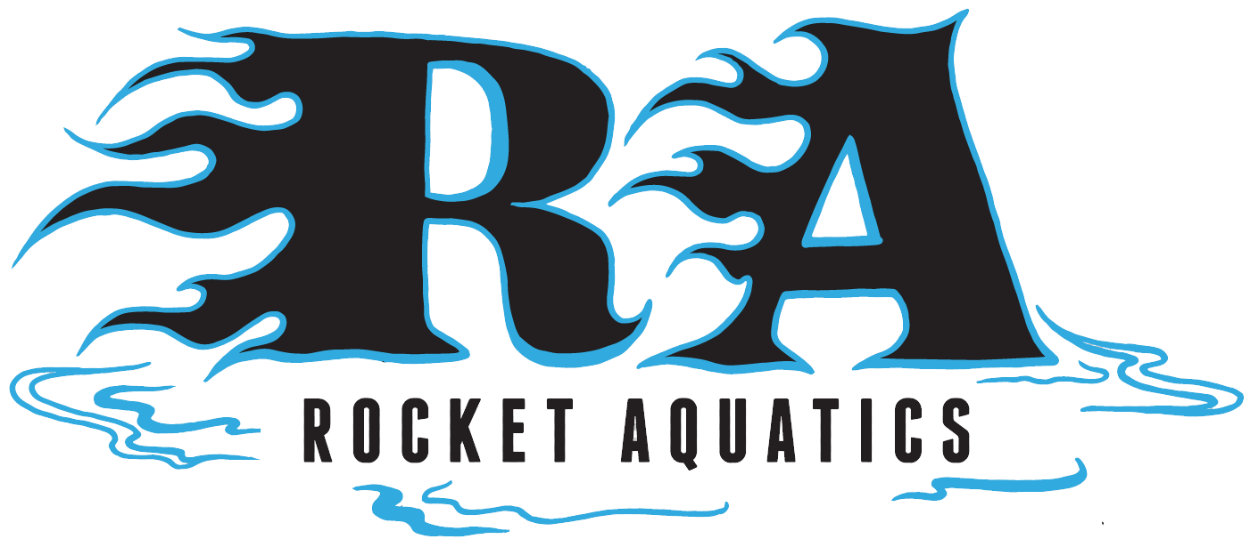

Pre-Competitive Learn to Swim
Summer Session 2

If your child is between the ages of 4-9 swam in our first summer session and is interested in improving and developing basic swimming strokes geared towards competitive swimming, building endurance, swimming and having fun this is the program for you!! It is a very safe environment and the instructor to swimmer ratio is very low.

Location: Menomonee Falls High School Pool
Tuesdays and Thursdays 6:30-7:00 or 7:00-7:30pm
July 13th – August 12th (No practice July 29th)
Cost: $135 for a total of 9, 30-minute sessions
There is a 1:3 – 1:5 teacher student ratio
30-minute sessions will be capped at 20 swimmers

Please visit our website, www.Rocketaquatics.org for more information. Click the “Swim Clinics” tab on the right-hand side of the website. All detailed information and a link to online registration can be found there. If you have any other questions, contact Coach Scott Mueller: (262)-347-7107 or email coachscottmueller@gmail.com.

