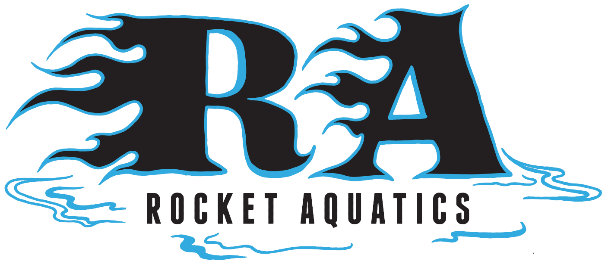

Pre-Competitive Learn to Swim

If your child is between the ages of 4-9 and is interested in improving and developing basic swimming strokes geared towards competitive swimming, building endurance, swimming and having fun this is the program for you!! It is a very safe environment and the instructor to swimmer ratio is very low.

Summer Pre-Competitive Swim (Ages 4-9)
Location: Menomonee Falls High School Pool
Mon, Tuesdays and Thursdays 6:30-7:00 or 7:00-7:30pm
June 14th – July 12th (No practice July 5th)
Cost: $160 for a total of 12, 30-minute sessions
There is a 1:3 – 1:5 teacher student ratio
30-minute sessions will be capped at 25 swimmers

Please visit our website, www.Rocketaquatics.org for more information. Click the “Swim Clinics” tab on the right-hand side of the website. All detailed information and a link to online registration can be found there. If you have any other questions, contact Coach Scott Mueller: (262)-347-7107 or email coachscottmueller@gmail.com.

