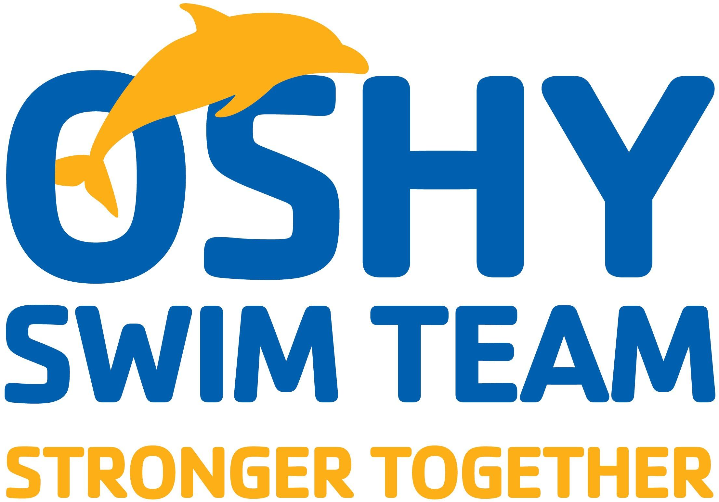

SPONSOR DATA SHEET
Contact: Josh Leggett
OSHY Swim Team Parent Board Member
(920) 216-0238
jmkleggett@sbcglobal.net

CHAMPION MEET SPONSORS
Consideration: Supporting area youth athletics by becoming a Sponsor of the OSHY YMCA Swim Team for the largest Meet of the year and the 2018/2019 Swim Series.

Overview: OSHY is uniquely privileged to have the opportunity of hosting 2 national level swimming champions to both train with our swimmers and share their experience as a part of a competitive swim meet. This meet is among the year’s most popular event for swimmers throughout the State. 2018 will celebrate its 16th year of providing thrills and life memories for countless swim families.

OSHY asks for your support in making this year’s Champion Meet the grandest and most impactful event to date.

2018 dates: November 16th-18th

Sponsorship Facts:
- Expected number of participating athletes: 1500+
- Expected number of family joining to support the athletes 3,750
- Expected number of swim teams in attendance: 25+
- Team geographical representation: Fox Valley, Greater Milwaukee, Greater Madison, Central WI, MI’s Upper Peninsula, and occasionally northern IL and IA.
- OSHY volunteers contribute over 2,800 hours in various jobs over the course of the Meet.
- Number of memories and smiles created: Countless!

Sponsorship Recognition:
In exchange for your support, Sponsors will receive acknowledgements according to the level of sponsorship. These can be customized to maximize your exposure.

Sponsorship Opportunities:

OPPORTUNITY | DESCRIPTION | RECOGNITION | AMOUNT
Title Sponsorship | The Event Naming Sponsor is given privileges and recognition unique to the Sponsor’s request (subject to OSHY YMCA’s approval). | Title recognition at entrances - Sponsor Package | $5000
Sponsorship of Champions | Two (2) Olympic, National or College champions fees, swimmer talk & training, room and board | Sponsor Package | $ 3500
Scoreboard Sponsorship | The OSHY Scoreboard Sponsor is contracted on an annual basis beginning in June of each year. A logo’d sign of a single Sponsor will be placed atop the OSHY scoreboard. The scoreboard is used during all indoor hosted meets (5) and is on year-round display | Signage on scoreboard + Sponsor Package | $ 2500
Meet Program Sponsorship | Professionally printed and bound program free give away to all attendees including team info, heat sheets, sponsors ($8 value) | Program cover + Sponsor Package | $ 350
50/50 Raffle | Cash prize raffle drawing for a family of four to have dinner with our champions Saturday night of the Champions Meet weekend at an Oshkosh restaurant | In-person dinner | $250
Heat Sheet Program Ad | Produce an ad for insertion to the meet heat sheet letter size color printed and bound program. This is handed out to all who attend the event including participants, parents, friends, for free. Your name will also appear in the heat sheets for all 2018-2019 Swim Series meets. | Program ad; 4 Sizes ⅛ page, ¼ page, ½ page and e, full page | $125  $250  $500  $1,000
 | Other Sponsorship Needs and Opportunities
Design A Duck | Swimmers and visitors select a white duck for a $2 and decorate the duck as they like. The proceeds from the sale of these ducks benefits the local charity chosen for the Champions meet each year. Sponsors are needed to purchase the ducks to be decorated. | Banner + Sponsor Package | $ 300
Bag Tags | All swim participants receive an OSHY Champion Meet bag tag | Logo on tag + Sponsor Package | $ 150

Sponsorship Package Includes:
- Champion meet & greet catered lunch
- Sponsor logos’ be assembled on a large Sponsor Banner. The banner will be displayed along the poolside deck and in lobby during the Meet
- Company logo included on email marketing to swimmers and parents regarding event
- On the Sponsors page contained within the meet Heat Sheet (the “daily event schedule”)
- On the Sponsors page of the OSHY website for 1 month before, during and 1 month after event
- Public address mention during meet multiple times

What we need from you:
Upon your decision to become a Sponsor, OSHY simply requires three items:
- Your monetary contribution or acknowledgment of the donated product/service. Please make your sponsorship check payable to: ** The OSHY YMCA.
- A digital copy of your entity’s logo artwork to be used for Sponsor acknowledgments. Vector logo.ai, and .eps, files preferred. PDF files can also be used.
- The email contact information for OSHY sponsorship information, updates, and questions.

Thank You for your consideration:
OSHY is very proud of, and works year-round, to prepare for these unique events. These are not your typical locally-based swim meets. They have far reaching impact to not only the surrounding Fox Valley area, but also many communities from around the state.
Enthusiasm abounds amongst swimmers and parents alike when given the opportunity to compete in one of the best swim facilities in Northeast Wisconsin. We formally invite you to become a noted contributor to this positive excitement!

We appreciate your thoughtful consideration of becoming a sponsoring partner of the OSHY YMCA Swim Team.
With kindest regards,
The OSHY Parent Steering Committee

OSHY Contact Information

OSHY Parent Board Contact: Josh Leggett ( jmkleggett@sbcglobal.net)

OSHY Head Coach: Jay Coleman ( jaycoleman@oshkoshymca.org )

OSHKOSH YMCA/OSHY Liaison: Jeff Schneider ( JeffSchneider@oshkoshymca.org )

OSHY Mailing Address:
OSHY
Oshkosh YMCA
3303 W 20th Ave, Oshkosh, WI 54904

501(c)3 EIN#: 39-0878909

About Oshy Swim Team
Established in the 1960’s, The Oshkosh YMCA Swim Team based out of the 20th Avenue aquatic center under the coaching leadership of Jay Coleman works with children ages 05 - Senior year in High School. Swimmers are coached and train during practices where membership in the team provides opportunities to improve times and make officially sanctioned USA Swimming local, regional, state and national competitions. The team is committed to producing outstanding individuals. An experienced coaching staff will teach the merits of hard work, team work, goal setting, and discipline in a positive and supportive environment to enable each swimmer to excel both in and out of the water. For information about Oshy Swim Team and how they are stronger together, visit http://oshyswimteam.org.

About Oshkosh YMCA
The Oshkosh Community YMCA is a not-for-profit organization whose purpose is to enhance lives by providing quality programs and facilities which will develop and maintain Christian values and ideals. No person shall ever be denied the services of the YMCA due to financial reasons. Scholarships are available. Aid is made possible thanks to YMCA contributors. For information about the Oshkosh YMCA, visit www.oshkoshymca.org
About USA Swimming
As the National Governing Body for the sport of swimming in the United States, USA Swimming is a 400,000-member service organization that promotes the culture of swimming by creating opportunities for swimmers and coaches of all backgrounds to participate and advance in the sport through clubs, events and education. Its membership is comprised of swimmers from the age group level to the Olympic Team, as well as coaches and volunteers. USA Swimming is responsible for selecting and training teams for international competition including the Olympic Games, and strives to serve the sport through its core objectives: Build the base, Promote the sport, Achieve competitive success. For more information, visit www.usaswimming.org and www.wisconsinswimming.org

