Come Join Our Team !!
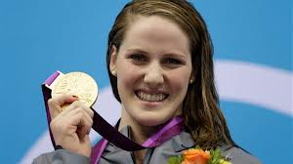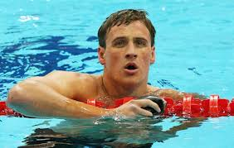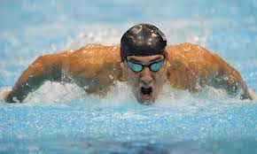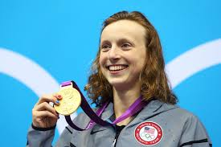
Olympians Missy Franklin, Ryan Lochte, Michael Phelps and Katie Ledecky all started with their local
USA Swimming Team – why don’t YOU give the Shorewood Swim Club a try!!

The Shorewood Swim Club will be having assessments for new swimmers on Wednesday, March 25th from 7:00-7:30 in the VHE Pool at Shorewood High School. Registration for the team immediately follows the assessment starting at 7:30, and the registration material can be found online at www.shorewoodswimclub.com . Parents should contact Head Coach Dave Westfahl (information is listed below) to schedule a session.

New swimmers should have completed Level 4 in Red Cross lessons (or the equivalent), be comfortable in the water, and be able to swim one length front crawl with rotary breathing to be ready for the team. New swimmers must attend the assessment in order to determine readiness for the team and appropriate group placement. Parents and coaches will be available at the assessment to help answer questions.

The Shorewood Swim Club features the following:

- Year Round competitive swim team with over 150 athletes
- Professional Coaching staff, certified by USA Swimming, Red Cross, and ASCA
- Progressive teaching and training curriculum
- Nine swim groups, providing optimal coach/swimmer ratios and lane space
- Convenient practice times in the afternoon and early evening
- Athletes ranging from Novice to Olympic Trial Qualifiers

If you have any questions prior to the assessments, please contact one of the following:

Executive Director/Head Coach David Westfahl
davewestfahl@shorewoodswimclub.com 861-7946

Please visit our web site at www.shorewoodswimclub.com for more information about the team!

