VAST Spring Fling 2022 -- WI Sanction #WI2022-247S
DATE: Sunday - May 22, 2022
LOCATION: Verona Area High School Aquatic Center
234 Wildcat Way, Verona, WI 53593

FACILITY: 25-yard Indoor 8-lane pool that opened in 2021
Starting depth: 7.0 feet
Turn depth: 3.5 feet
Regulation-height starting blocks (30")
Ample viewing area for athletes and spectators
Concessions WILL BE available

MEET DIRECTOR: Mylinda Heil. mylindaheil@tds.net, 608-215-4073
ADMIN OFFICIAL: Sarah Olson
OFFICIALS: Meet Referee, Matt Lorson – Lorson145@gmail.com.
Deck Referee, Andrew Olson
There will be a minimum of three other officials.
ENTRIES COORDINATOR: Jennifer and Mike Chapman – swimvast@outlook.com
CLASSIFICATION: AM Session: 13/14 and Open PM Session: 10-Under, 12-Under
SCHEDULE:
Sunday A.M. Warm-ups start at 7:30 am
AM Meet starts at 8:30 am
Sunday P.M. Warm-ups 10 minutes after the conclusion of the A.M. session
PM Meet Start Time: One hour after the start of the PM Warm-ups.

An estimated timeline will be posted once all entries are submitted.
MEET LANDING PAGE URL:

https://www.teamunify.com/team/wivast/page/hosted-meets

This page will be updated as we get closer to the meet. PDF’s of heat sheets and updated timelines will be posted.

WAIVER: All Athletes, Coaches, Officials, Volunteers and Vendors must complete this waiver. Please use the following Google form link to complete this. One for each person.

https://docs.google.com/forms/d/e/1FAIpQLScJrlUD0mrMJhzMmXQ6EZoeDpAIzy6NMNCX6m1m8VeYgiz7RA/viewform?usp=sf_link

COVID -19 RISK ACKNOWLEDGEMENT:

In applying for this sanction(ed event), the Host, Verona Area Swim Team agrees to comply and to enforce all health and safety mandates and guidelines of USA Swimming, Wisconsin Swimming, Inc., the State of Wisconsin and the Dane County Health Department

We have taken enhanced health and safety measures – for you, the other participants, and meet staff. You must follow all instructions while visiting the Verona Area Aquatic Center. An inherent risk of exposure to COVID-19 exists in any public place where people are present. COVID-19 is an extremely contagious disease that can lead to severe illness and death. According to the Centers for Disease Control and Prevention, senior citizens and guests with underlying medical conditions are especially vulnerable. By visiting Verona Area Aquatic Center, you voluntarily assume all risks related to exposure to COVID-19.

An inherent risk of exposure to COVID-19 exists in any public place where people are present. COVID-19 is an extremely contagious disease that can lead to severe illness and death. According to the Centers for Disease Control and Prevention, senior citizens and individuals with underlying medical conditions are especially vulnerable.
USA Swimming, Inc., cannot prevent you (or your child(ren)) from becoming exposed to, contracting, or spreading COVID-19 while participating in USA Swimming sanctioned events. It is not possible to prevent the presence of the disease. Therefore, if you choose to participate in a USA Swimming sanctioned event, you may be exposing yourself to and/or increasing your risk of contracting or spreading COVID-19

BY ATTENDING OR PARTICIPATING IN THIS COMPETITION, YOU VOLUNTARILY ASSUME ALL RISKS ASSOCIATED WITH EXPOSURE TO COVID-19 AND FOREVER RELEASE AND HOLD HARMLESS USA SWIMMING AND WISCONSIN LSC AND EACH OF THEIR OFFICERS, DIRECTORS, AGENTS, EMPLOYEES OR OTHER REPRESENTATIVES FROM ANY LIABILITY OR CLAIMS INCLUDING FOR PERSONAL INJURIES, DEATH, DISEASE OR PROPERTY LOSSES, OR ANY OTHER LOSS, INCLUDING BUT NOT LIMITED TO CLAIMS OF NEGLIGENCE AND GIVE UP

ANY CLAIMS YOU MAY HAVE TO SEEK DAMAGES, WHETHER KNOWN OR UNKNOWN, FORESEEN OR UNFORESEEN, IN CONNECTION WITH EXPOSURE, INFECTION, AND/OR SPREAD OF COVID-19 RELATED TO PARTICIPATION IN THIS COMPETITION.

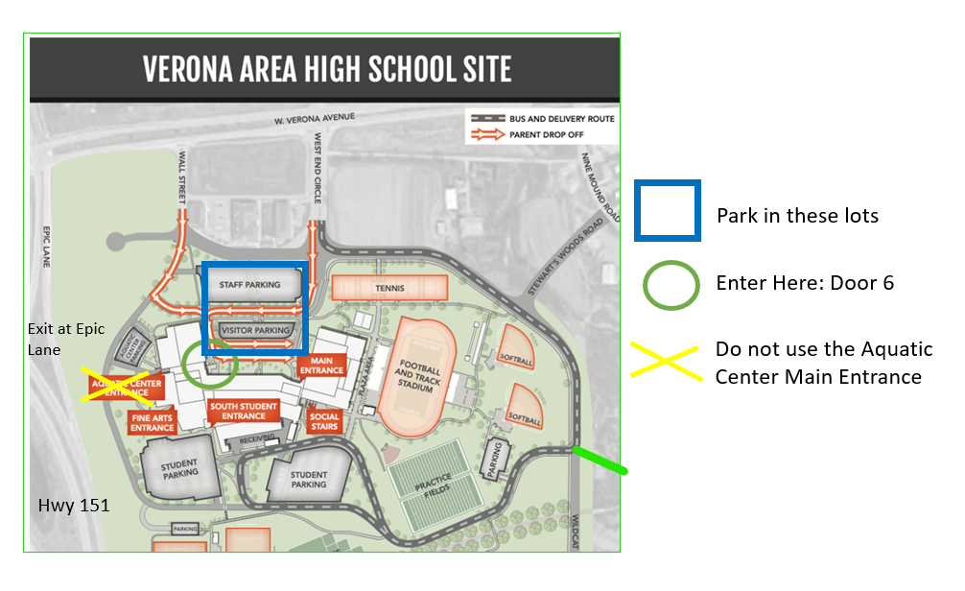
PARKING: Everyone should plan to park in Lot A and Lot B which are the lots facing the Kwik Trip in front of the high school. Everyone should enter Door #6. SEE THE MAP ABOVE. Athletes will turn left at the welcome table and head toward the locker rooms. Spectators will continue in the hallway/stairs up to the second level. There is a nearby elevator available for any visitor that requires it.
WARM-UPS: Warm up times and lanes will be published as soon as all team entries and swimmer count per session are known. Feet-first, three-point entries from the starting end of the pool during general warm-ups will be enforced in accordance with the recent change to Wisconsin Policy 4.5.2(a). These will be posted on the Vast Meet homepage. Link on the first page.
No equipment: including ear buds, pull buoys, kick boards, or paddles.
ENTRIES: Swimmers may compete in four (4) individual events and two (2) relays. Entries will be accepted up to a maximum of 1600 swims.
This meet will be run using Hy-Tek Meet Manager. All teams are encouraged to submit entries on disk or e-mail in the Hy-Tek commlink format. Swimmers competing without a Team representative should contact Emily Paradis by email to coachemily@swimvast.com about entry into the meet. You can download a meet setup file (zipped) from the WI website.
DECK ENTRIES: Will be accepted if there are any open lanes for the event at a $8.00 fee. All deck entries MUST be requested no later than 30 minutes before the start of the session. Switching out of one event to another will not be allowed. No on-site USA registrations will be accepted.
ENTRY PERIOD: 1st date for submission is Monday April 25th through Monday May 16th, 2022. E-MAIL entries are required. Please include a hard copy of your entry with your email. You will receive an email confirmation of your entry within 24 hours. Please look over and confirm it matches your entry. If you have not received that confirmation, please email or call Mylinda Heil at 608-215-4073. Waiver and fees must be received by the start of the meet. E-mail entries to: swimvast@outlook.com. Bring the waiver and check to the meet, no need to mail beforehand.
ENTRY FEES: $4.00 LSC splash fee per swimmer, $5 per individual event. $12.00 per relay. $10.00 Facility Charge. For swimmers entering without a commlink file a $5.00 per swimmer charge will be accessed for hand entering.
EVENTS:
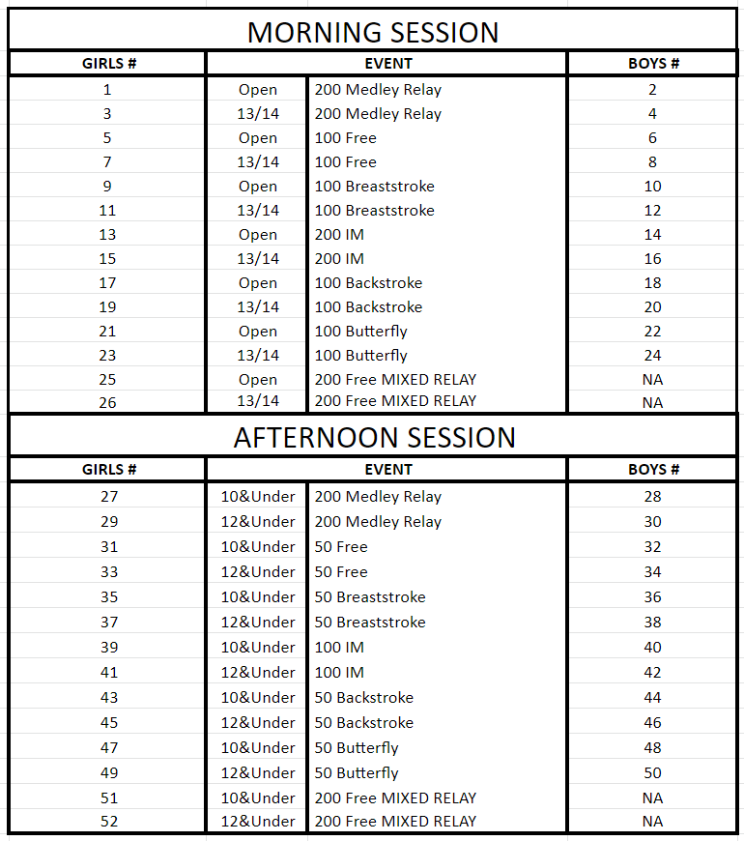

ADMISSIONS: No admission charge for spectators.
HEAT SHEETS: A PDF will be added to the VAST Meet Landing page and will be available on Meet Mobile.
TIMING SYSTEM: All events will be timed using Daktronics with horn start, touch pads, two buttons, and a minimum of one watch as backup. 25-yard races may be timed with two buttons and a minimum of one watch as backup.
SCORING: Individual events: 9, 7, 6, 5, 4, 3, 2, 1. Relays score doubles.
AWARDS: Ribbons for individual age groups (10U and 12U) will receive 1st through 8th place. Relay events will be awarded for 1st through 3rd place for 10-Under, 12-Under. Heat winner awards will also be handed out on deck.
No awards will be mailed or kept after the meet. Swimmers may pick up their awards at the awards table. All remaining awards will be bagged and available for coaches to take at the end of the day.
DIFFERENTLY ABLED ATHLETES: On the entries form, please indicate any special needs for those athletes’ requiring assistance. Also, please inform the head official of those needs prior to the start of the meet.
RULES: This meet will be conducted under USA Swimming 2022 and Wisconsin Swimming Rules . The Competition Course has not been certified in accordance with USA Swimming’s Rule.
Current USA Swimming Rules, including the Minor Athlete Abuse Prevention Policy (“MAAPP”), will govern this meet. A registered athlete member at a sanctioned/approved meet who is 18 years of age or older, who had not completed the Athlete Protection Training (APT) by the date of the swim, will not be able to upload into SWIMS. These athletes will also be considered “not in good standing” and can be subject to fines under Wisconsin Swimming Policy 11.2.1.
CONCESSIONS: Concessions will be available throughout the day. Bagels, fruit, bars, pizza, Gatorade, water, soda, candy, etc. will be available.
LOCKER ROOMS/RESTROOMS: Only swimmers should be utilizing the locker rooms and locker room bathrooms. Meet Marshalls will sweep through locker rooms throughout the meet to verify cleanliness and safety. Swimmers should not congregate in any locker room. Coaches and Officials will use a separate designated restroom area. All parents and visitors shall use the restrooms on the second level near concessions in the hallway just outside of the spectator seating area.
LIVE STREAM: Not available for this meet. There is a closed-circuit TV that can be viewed from the TVs in the building hallways.
FINAL RESULTS: Complete meet results in pdf format plus MM back up and TM files will be sent to be posted on the WI web after the conclusion of the weekend.

VAST SPRING FLING 2022
WI SANCTION # 247S
Waiver of Liability, Release, and Indemnity Agreement
“You and Your” refers to [check the appropriate selection]:
___ participant (if participant is 18 or older) ___ Participant Parent/Guardian (if participant is a minor)
__________ You acknowledge the contagious nature of COVID-19 and voluntarily assume the risk that your family, including child(ren), may be exposed to or infected by COVID-19 while on site at the pool or facility and that such exposure or infection may result in personal injury, illness, permanent disability, and death. You understand that the risk of becoming exposed to or infected by COVID-19 at the pool or facility may result from the actions, omissions, or negligence of myself and others, including, but not limited to, the Verona Area Swim Team and pool management company's employees, volunteers, and program participants and their families.
__________ You acknowledge, Verona Area Swim Team, Wisconsin Swimming, Inc., and USA Swimming, Inc., cannot prevent you (or your child(ren)) from becoming exposed to, contracting, or spreading COVID-19 while participating in USA Swimming sanctioned events. It is not possible to prevent the presence of the disease. Therefore, if you choose to participate in a USA Swimming sanctioned event, you may be exposing yourself to and/or increasing your risk of contracting or spreading COVID-19.
_________ You agree that you, or your child, are voluntarily participating in these activities, with knowledge of the risks associated with such activity.
_________ You acknowledge and agree that neitherVerona Area Swim Team, Wisconsin Swimming, Inc., and USA Swimming, Inc., nor you will be liable to the others for any special, indirect, incidental or consequential damages arising out of this Agreement. Except as otherwise specifically set forth herein, Verona Area Swim Team, Wisconsin Swimming, Inc., and USA Swimming, Inc.’s total liability to you under or in connection to this Agreement shall not exceed the amounts paid or payable to Verona Area Swim Team, Wisconsin Swimming, Inc., and USA Swimming, Inc. according to this agreement; Any action against Verona Area Swim Team, Wisconsin Swimming, Inc., and USA Swimming, Inc. arising out of, resulting from, or related to the performance or breach of this Agreement shall be filed not later than three (3) months after the cause of action has accrued.
_________ You agree that should any part of this agreement be found by a court of law to be against public policy or in violation of any state statute or case precedence, then the remainder of this document will remain in full force
_________ By signing below, you understand and agree to the terms stated above. You understand the risks associated with Swimming Competition. IN ADDITION, BY SIGNING BELOW, YOU RELEASE [INSERT CLUB NAME], WISCONSIN SWIMMING, INC., AND USA SWIMMING, INC. FROM ANY AND ALL LIABILITY FOR ANY INJURY OR DAMAGE THAT MAY ARISE FROM, BUT NOT LIMITED TO, YOUR PARTICIPATION IN (A) ANY ACTIVITY, CLASS, PROGRAM, PERSONAL TRAINING OR INSTRUCTION, (B) THE SUDDEN AND UNFORESEEN INJURIES ARISING OUT OF YOUR IMMEDIATE SURROUNDINGS, (C) OUR INSTRUCTION, TRAINING, OR SUPERVISION. THE FOREGOING UNDERSTOOD, YOU, YOUR HEIRS, ASSIGNS, AND YOUR PERSONAL REPRESENTATIVE HEREBY RELEASE AND WAIVE ANY AND ALL CLAIMS AGAINST [INSERT CLUB NAME], WISCONSIN SWIMMING, INC., AND USA SWIMMING, INC., ITS OWNERS, OFFICERS AND EMPLOYEES, CONTRACTORS, AND ANY OTHER PARTIES CONNECTED TO THE SERVICES IN ANY WAY (“RELEASEES”) SINGULARLY OR COLLECTIVELY, AND FURTHER HOLD HARMLESS AND INDEMNIFY SUCH RELEASEES FROM AND AGAINST ANY LIABILITY, CLAIMS OF NEGLIGENCE, MISADVENTURE, HARM, LOSS, INCONVENIENCE OR DAMAGE HEREBY SUFFERED OR SUSTAINED AS A RESULT OF YOUR PARTICIPATION IN THE SERVICES, OR ANY OTHER SERVICES OR ACTIVITIES OFFERED BY RELEASEES. THE FOREGOING NOTWITHSTANDING, THIS IS NOT A RELEASE AND WAIVER OF INTENTIONAL OR RECKLESS ACTS OF RELEASEES. SUCH RELEASE, WAIVER, HOLD HARMLESS AND INDEMNITY SHALL APPLY TO YOUR OWN CLAIMS AND/OR CLAIMS OF THIRD PARTIES, RELATING TO MY PARTICIPATION IN THE SERVICES.
YOU HAVE READ AND UNDERSTAND THIS AGREEMENT. YOU HAVE HAD THE OPPORTUNITY TO BARGAIN WITH [INSERT CLUB NAME], WISCONSIN SWIMMING, INC., AND USA SWIMMING, INC. WITH ADEQUATE INSURANCE OR AN ADEQUATE CASH DEPOSIT TO NOT HAVE TO AGREE TO THE WAIVERS OR RELEASES OF LIABILITY OR INDEMNIFICATION PROVISIONS SET FORTH HEREIN. YOU UNDERSTAND THAT YOU HAVE WAIVED AND SURRENDERED VALUABLE LEGAL RIGHTS. YOU HAVE SIGNED THIS WAIVER VOLUNTARILY; AFTER DUE NEGOTIATIONS, IN EXCHANGE FOR THE CONSIDERATION DESCRIBED ABOVE.
This Agreement and its terms bond a relationship between Verona Area Swim Team, Wisconsin Swimming, Inc., and USA Swimming, Inc. and yourself. Each time you participate in these activities, you affirm the terms of this Agreement and agree to indemnify and hold Verona Area Swim Team, Wisconsin Swimming, Inc., and USA Swimming, Inc. and its employees harmless from all liability and claims, as stated above.
The Services are provided under this Agreement by Verona Area Swim Team, through sanction by Wisconsin Swimming, Inc., and USA Swimming, Inc.
Participant or Parent/Guardian Signature: _________________________________________
Date: _______________________
Participant or Parent/Guardian Name (print): _______________________________________
Participant or Parent/Guardian Phone Number: ________________

