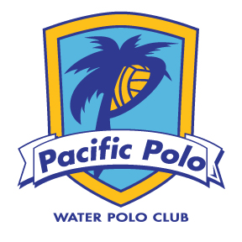
16U & 18U Girls
2018 Summer Water Polo Program (June 5th – July 25th)
The Summer Championship Season is upon us. Stay cool in the pool (and out of trouble) this summer to prepare and compete against the highest level of competition. We will focus on conditioning, mechanics, fundamentals, and advanced frontcourt offense and backcourt defense. We’ve already signed up for weekly league games and tournaments to stay sharp and propel our top athletes into the National Junior Olympics in late July.
Practices: Tues & Thurs: 7-9PM @ Westview HS
Mon & Wed: 7-9AM @ Westview HS
*Mon and Wed mornings will start the week after school gets out on June 18th
Summer Fee: $475 Please mail a check (payable to Pacific Polo) to 13218 Wanesta Dr., Poway 92064 or pay online via Credit Card
Summer Games and Tournaments: *Other tournaments will be available as well!
Summer League Games Weekly (San Diego $45/player):
18U Mondays June 18th, 25th, July 2nd, 9th and 16th
16U Wednesdays June 13th, 20th , 27th, July 11th and 18th
Regional JO Qualifiers (Coronado): June 18-24th
(One 16U Team & one 18U Team - $75/player due by May 23rd)
CHAWP (Inland Empire, CA): or Cal State Games in San Diego July 13-15th (All athletes invited to attend - $80/player)
National Junior Olympics (San Jose, CA): July 26-29th ($250/player *50% deposit due by May 23rd)
Coaching Staff: Emma Sasson, Jae Crabtree, Mason Rafferty (goalies)
********All Athletes Must Be Current USAWP Members********
Questions? Contact Coach Emma (cell; text ok) or email (858) 829-7064 or emma.h.sasson@gmail.com or Coach Jae (858) 603-9177 jaecrabtree14@gmail.com

