CASPER SWIM

January 2015
CLUB

From the Desk of Coach John:
Many parents have questions about their child’s best times and if they are qualified for state, zones, etc…and how they can figure that out for themselves.

One of the ways this can be accomplished is to review various websites such as www.usaswimming.com for your childs best recorded swim times and qualifying times for national level meets.
State qualifying times may be found at www.wyomingswimming.org.
Zones qualifying times may be found at www.wyomingswimming.org or https://www.teamunify.com/TabGeneric.jsp?_tabid_=12738&team=wzone .

Or, you can download “OnDeck Parent” from the Apple app store or the Android store.
This app is tremendous! In addition to storing all of your childs best times, it recognizes what meet the times were swum in, as well as what the splits for that race were.
Also, it can download and store the qualifying times for every event your child swims!
Please review the following screenshots for what the app looks like on the store as well as the functions of the various menu items.
If you do download the app, you will need our club code, which is wycsc.

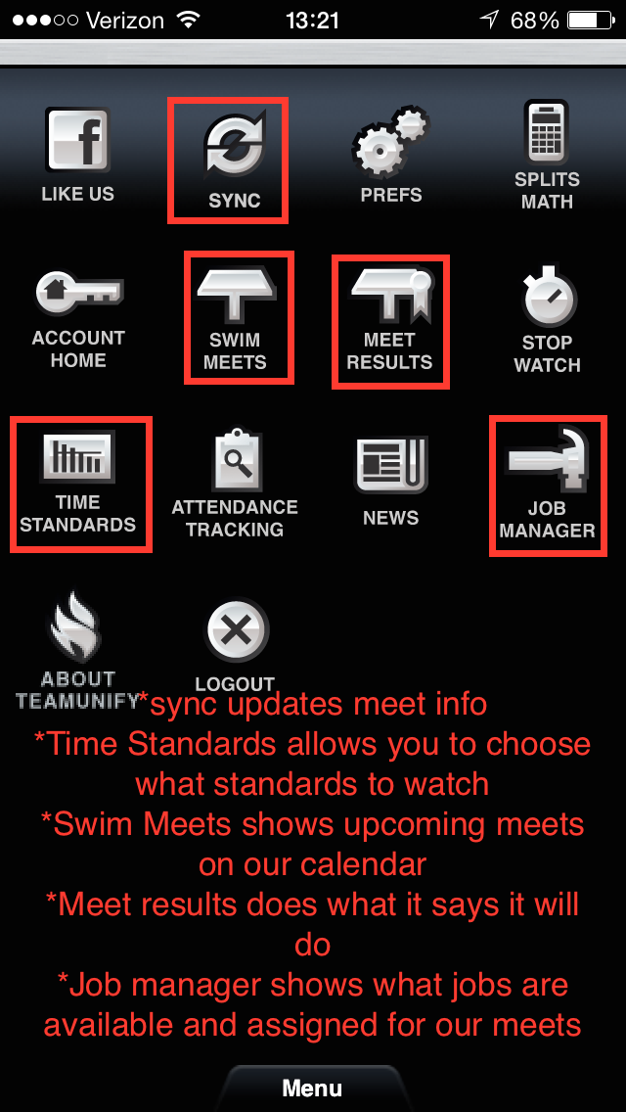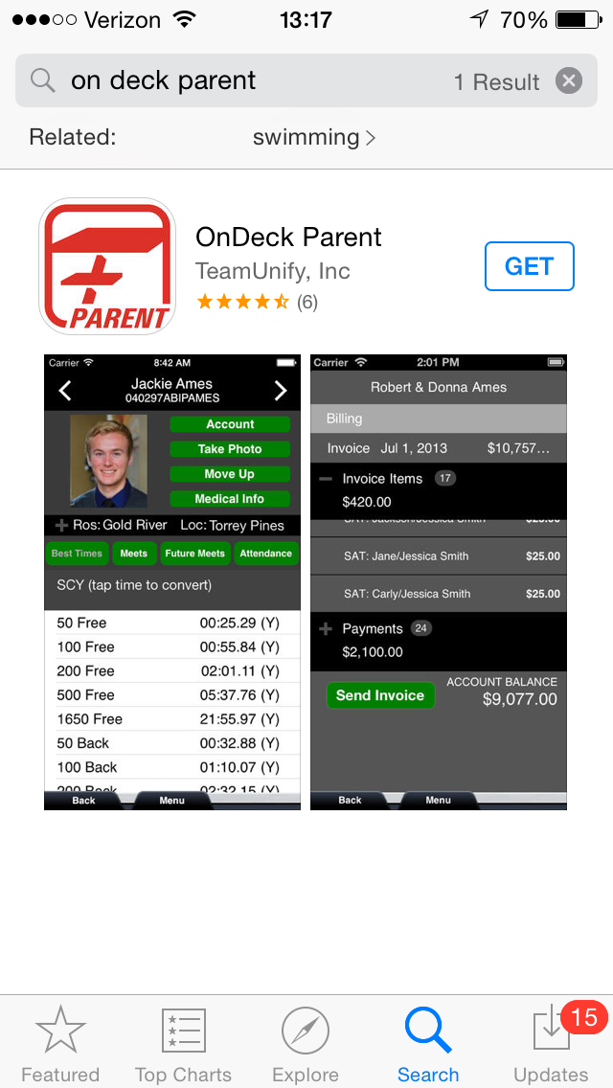

Upcoming elections:
We will be holding elections for several board positions this spring. We will be looking for people willing to fill the Vice President and Treasurer positions. This is a great way to help out the swim club and keep things running smoothly for our kids! Here is a brief description of the duties of each office:
Vice President: Oversees fundraising activities. Oversees USA swim club card enrollment. Takes care of renewing the charter for swim club. Takes over the duties of president as necessary.
Treasurer: Takes care of billing and collecting dues and meet fees. Pays swim club employees. Prepares monthly billing statements for the swim club. Takes care of taxes and W2s for swim club.
If you are interested in either of these positions or need more information, please let one of us know. Or you can send an e-mail to secretary@casperswimclub.org. The Casper Swim Club Bylaws also have more detailed descriptions of the different offices, and are available on our website. Just go to the “Menu” tab and look under “Documents.”
The office of meet director will also come up for election next spring. The person in this position is responsible for coordinating and running all home meets. It is a position that requires a little training and mentoring, so if you think you might be interested, we’d love to know now so we can start the training process early.

Upper parking lot:
Please don’t use the upper parking lot by the pool. This area is reserved for handicapped parking, and we can be ticketed for using it. In addition, it is not cleared in the winter, and gets dangerous during busy practice and meet times. Several cars have slid backwards down the ramp over the last week because of ice and snow. Instead, please use the lot at the bottom of the hill to the north of the pool.
Contact information:
Please be sure to update your e-mail addresses on our swim club website. E-mail is the only way we have to reach you about meets and other important information, so if your e-mail address isn’t current, you won’t be hearing from us and might miss something. Also, check your spam folder from time to time, to make sure our e-mail isn’t getting sent there.
Finally, while you are checking your information to be sure it is current, please be sure we have correct credit card information on file if you are paying by credit card. And check the sizes you have listed for your kids to make sure they haven’t outgrown the sizes we have on file. We use the listed sizes on the website when we are ordering T-shirts and other apparel for the kids.
Having your information up-to-date really helps our club run more smoothly, and we appreciate it! So thanks in advance for double-checking this for us.
Scholarship:
Did you know that the swim club offers a college scholarship to members? If you are interested in applying, please e-mail secretary@casperswimclub.org and we can get you more information.
B state meet is coming!
Our “B” state meet is coming up February 21-22, 2015. While we always rely on parent participation and volunteerism to help our meets run smoothly, the “B” state meet is our biggest meet, and so we’ll be relying on you more than ever to help out! As the meet gets closer, we’ll send out requests for help. Please sign up to help out so we can provide a really great event for all our kids!

Apparel:
Between ordering T-shirts for the various meets we host and selling apparel at the meets to help our fundraising efforts, we spend a lot of time coordinating apparel. We’d love to have someone willing to help with this, especially during “B” state, when the board will be very busy making sure the meet runs smoothly. This is not an elected board position, but we’d love to have a volunteer willing to help us coordinate it. If you are interested, please e-mail secretary@casperswimclub.org.

