TRAINER GUIDE
OFFICIALS RESOURCES
Become familiar with the USA Swimming website, since this site contains useful up-to-date information for officials. The link is http://www.usaswimming.org .

To get to the Officials part of the USA Swimming website, click on the “Member Resources” tab and then “Officials”. The main Officials page contains many useful page links, including the following:

Test & Certification – allows officials to print or take an online test
Education & Training – contains useful officiating articles

Within Education & Training is “Education & Training Resources”, which includes the Officials’ Manual / Guide to Officiating, along with articles under “Training Resources”, “Situations & Resolutions” and “Articles and Presentations”.

The USA Swimming rulebook can be found online under the “About” tab and “Rules & Regulations”.

CCS periodically has training clinics for officials. USA Swimming also has an excellent stroke and turn training video for officials called Officiating Swimming.
STEPS TO BECOME AN OFFICIAL
- Participate and demonstrate knowledge of strokes/rules during training sessions
- Register with USA Swimming as an official
- Take and pass the Stroke & Turn open book online test
- Take Athlete Protection Training
- Participate in a background check
SESSION 1 & SESSION 2: Overview
Give copy of rules and DQ slip to read. (Article One 101.2-101.7 and Article Two 102.10)

Review stroke rules
Explain the importance of learning swim terminology, i.e., butterfly-type kick opposed to dolphin kick

Professional Volunteer
A caring attitude is assured by neat appearance and focus on the swims
Always give benefit of doubt
Normal Dress: navy blue (SC) or khaki (LC) shorts/pants/skirts, white polo shirt, white tennis shoes
No cell phones, pagers, stop watches, or cheering
Retake officiating test every two years
Get background check every two years
Take athlete protection training annually (no charge)
Work minimum number of CCS sessions per year
Clubs are required to have officials at CCS meets to avoid fees

Official Positions – Briefly outline the duties of the following positions:
Referee (Rule 102.11)
Starter (Rule 102.12)
Chief Judge (Rule 102.13.1)
Stroke vs Turn Judge (Rule 102.13.3, 102.13.4)

Positioning
Impress importance of proper positioning to make undisputed calls
Stand upright
Stand at edge of pool
Observe all lanes equally
Backstroke start position

Be honest in your evaluation
SESSION 3: Overview
Review stroke rules

DQ Slips:
Raise hand immediately upon observing an infraction
Finish the heat
Complete DQ slip carefully
Inform the swimmer of the disqualification

Explain DQ Slip:
How to fill it out completely
Infraction terminology

Explain how to observe relay take-offs (Rule 102.13.6) and how to complete relay take-off slips.

Be honest in your evaluation
SESSION 4 & SESSION 5: Overview
Review stroke rules

Clarify questions about swimming words and terms

Be honest in your evaluation
SESSION 6: Overview
Allow trainee to be the active official

Complement good calls or non-calls

Help trainee recognize missed infractions
“If you see it, call it. If you’re not sure, it didn’t happen.”

Be honest in your evaluation
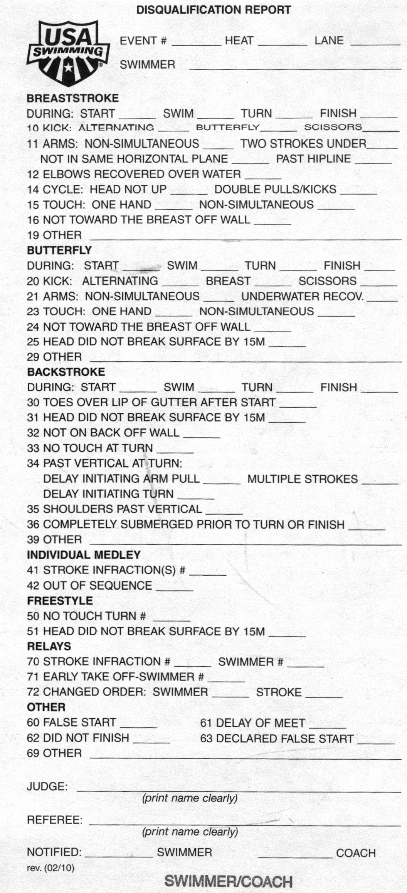
TRAINEE

SESSION 1
Read Rules: (4 strokes + IM)

Attire: Navy blue for short course or khaki for long course, white socks, and white tennis shoes. No stop watches, whistles, cell phones, or pagers (put on vibrate)

When we look different, we stand out, and our goal is to do our job invisibly.

Positions: Meet Referee
Deck Referee(s)
Starter(s)
Chief Judge
Stroke Judges
Turn Judges

Positioning: Turn
Stroke
Relay Take-off

Access the USA Swimming website and begin to become familiar with it. Read the Stroke and Turn Chapter in the Officials’ Manual / Guide for Officiating on the website.
TRAINEE COMMENTS:
Observations:
___________________________________________________________________________________________
___________________________________________________________________________________________
___________________________________________________________________________________________
___________________________________________________________________________________________
___________________________________________________________________________________________

Questions:
___________________________________________________________________________________________
___________________________________________________________________________________________
___________________________________________________________________________________________
___________________________________________________________________________________________
___________________________________________________________________________________________

TRAINER COMMENTS:

Observations:
___________________________________________________________________________________________
___________________________________________________________________________________________
___________________________________________________________________________________________
___________________________________________________________________________________________
___________________________________________________________________________________________

Questions:
___________________________________________________________________________________________
___________________________________________________________________________________________
___________________________________________________________________________________________
___________________________________________________________________________________________
___________________________________________________________________________________________

Training Date: _____________

Trainee: ___________________________ Trainer: ___________________________
SESSION 2
Review stroke rules.

Observe lanes as Stroke and Turn judge.
TRAINEE COMMENTS:
Observations:
___________________________________________________________________________________________
___________________________________________________________________________________________
___________________________________________________________________________________________
___________________________________________________________________________________________
___________________________________________________________________________________________

Questions:
___________________________________________________________________________________________
___________________________________________________________________________________________
___________________________________________________________________________________________
___________________________________________________________________________________________
___________________________________________________________________________________________
TRAINER COMMENTS:
Observations:
___________________________________________________________________________________________
___________________________________________________________________________________________
___________________________________________________________________________________________
___________________________________________________________________________________________
___________________________________________________________________________________________

Questions:
___________________________________________________________________________________________
___________________________________________________________________________________________
___________________________________________________________________________________________
___________________________________________________________________________________________
___________________________________________________________________________________________

Training Date: _____________

Trainee: ___________________________ Trainer: ___________________________
SESSION 3
Read Rules

Review Strokes

Read rules pertaining to relays

Familiarity with DQ slip – memorize it!

Observe relay takeoffs if possible.
TRAINEE COMMENTS:
Observations:
___________________________________________________________________________________________
___________________________________________________________________________________________
___________________________________________________________________________________________
___________________________________________________________________________________________
___________________________________________________________________________________________

Questions:
___________________________________________________________________________________________
___________________________________________________________________________________________
___________________________________________________________________________________________
___________________________________________________________________________________________
___________________________________________________________________________________________
TRAINER COMMENTS:
Observations:
___________________________________________________________________________________________
___________________________________________________________________________________________
___________________________________________________________________________________________
___________________________________________________________________________________________
___________________________________________________________________________________________

Questions:
___________________________________________________________________________________________
___________________________________________________________________________________________
___________________________________________________________________________________________
___________________________________________________________________________________________
___________________________________________________________________________________________

Training Date: _____________

Trainee: ___________________________ Trainer: ___________________________
SESSION 4
Read Official Glossary

Observe relay take-offs if possible

Print out the online test and start to fill it out at home. (Note that you must be a member of USA Swimming to do this.)
TRAINEE COMMENTS:
Observations:
___________________________________________________________________________________________
___________________________________________________________________________________________
___________________________________________________________________________________________
___________________________________________________________________________________________
___________________________________________________________________________________________

Questions:
___________________________________________________________________________________________
___________________________________________________________________________________________
___________________________________________________________________________________________
___________________________________________________________________________________________
___________________________________________________________________________________________
TRAINER COMMENTS:
Observations:
___________________________________________________________________________________________
___________________________________________________________________________________________
___________________________________________________________________________________________
___________________________________________________________________________________________
___________________________________________________________________________________________

Questions:
___________________________________________________________________________________________
___________________________________________________________________________________________
___________________________________________________________________________________________
___________________________________________________________________________________________
___________________________________________________________________________________________

Training Date: _____________

Trainee: ___________________________ Trainer: ___________________________
SESSION 5
Work with official trainer as observer

Observe relay takeoffs if possible (and haven’t already done it)

Print out the online test and start to fill it out at home if haven’t already done it. Try to take the online test prior to Session 6.
TRAINEE COMMENTS:
Observations:
___________________________________________________________________________________________
___________________________________________________________________________________________
___________________________________________________________________________________________
___________________________________________________________________________________________
___________________________________________________________________________________________

Questions:
___________________________________________________________________________________________
___________________________________________________________________________________________
___________________________________________________________________________________________
___________________________________________________________________________________________
___________________________________________________________________________________________
TRAINER COMMENTS:
Observations:
___________________________________________________________________________________________
___________________________________________________________________________________________
___________________________________________________________________________________________
___________________________________________________________________________________________
___________________________________________________________________________________________

Questions:
___________________________________________________________________________________________
___________________________________________________________________________________________
___________________________________________________________________________________________
___________________________________________________________________________________________
___________________________________________________________________________________________

Disqualifications: _________________________________________________ Rule(s): __________________
_________________________________________________ __________________
_________________________________________________ __________________

Training Date: _____________

Trainee: ___________________________ Trainer: ___________________________
SESSION 6
Arrange to be at pool by start of warm-ups

Spend time observing:
Referee
Starter
Clerk of Course (during check-in)

Observe relay takeoffs if possible (and haven’t already done it)

If comfortable (and have taken online test), work as an official with the official trainer as the observer.

Take the online test (if haven’t already). After taking the test, read “Situations and Resolutions” on the USA Swimming website under Education & Training Resources.
TRAINEE COMMENTS:
Observations:
___________________________________________________________________________________________
___________________________________________________________________________________________
___________________________________________________________________________________________
___________________________________________________________________________________________
___________________________________________________________________________________________

Questions:
___________________________________________________________________________________________
___________________________________________________________________________________________
___________________________________________________________________________________________
___________________________________________________________________________________________
___________________________________________________________________________________________
TRAINER COMMENTS:
Observations:
___________________________________________________________________________________________
___________________________________________________________________________________________
___________________________________________________________________________________________
___________________________________________________________________________________________
___________________________________________________________________________________________

Questions:
___________________________________________________________________________________________
___________________________________________________________________________________________
___________________________________________________________________________________________
___________________________________________________________________________________________
___________________________________________________________________________________________

Disqualifications: _________________________________________________ Rule(s): __________________
_________________________________________________ __________________
_________________________________________________ __________________

RECOMMEND: ____ Assign
____ Assign with observer
____ Additional training – specify area(s) ______________________________
Training Date: _____________

Trainee: ___________________________ Trainer: ___________________________

