 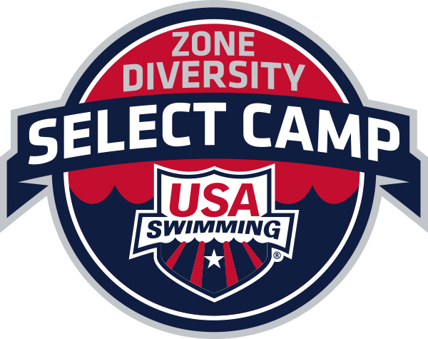

**WESTERN ZONE DIVERSITY and INCLUSION SELECT CAMP**

**and DIVERSITY SUMMIT**

**June 16 - June 19, 2016**

**University of Utah**

**Salt Lake City, Utah**

**Purpose:** Instill a vision of success and inspire athletes from under-represented populations to become leaders in the sport of swimming.

**Site: University of Utah, Salt Lake City, Utah.** The University of Utah is located in the foothills of the Wasatch Mountains in Salt Lake City. The Ute Natatorium features three pools: a six lane 25 yard training pool, an eight lane 25 yard competition pool and the newly refurbished 20x15 diving well. Participants will be housed on campus.

**Dates: June 16 - June 19, 2016.** Athletes and coaches will arrive Thursday late afternoon/ evening and depart Sunday morning. Summit participants will arrive Friday and depart Sunday morning.

**Application Deadline: April 15th, 2016**

**Age:** 13 -16 years of age at the time of the camp (9-10th grades)

**Funding:** Each LSC will fund two athletes, a coach, their Diversity Chair, and any Diversity Summit participants to the camp. Funding will need to include their transportation to and from the camp and an additional fee of $240.00 which will cover on campus rooming, all meal costs per person, and local event ground transportation including transportation to and from the airport in San Jose or Oakland to the camp site. Rooming costs are based on two person occupancy rooms.

**Athlete Qualifications:**

**Preferred Qualifications:** Athletes must have an "A" time in one or more events in any course either as a 13-14 or as a 15-16 year old athlete. Designate the time standard achieved and age on the application.

**Secondary Qualifications:** If an LSC has no athletes apply who meet the preferred qualifications then the LSC may select athletes who have qualified in at least one individual event in their local LSC championship meet in either SCY or LC seasons.

In the event that there are no qualifying swimmers, the LSC can elect to send two athletes (and alternates if accepted) of its choice.

**Additional Information:** If an athlete has attended a previous Western Zone Diversity and Inclusion Select Camp or a USA Swimming National Diversity Select Camp, the athlete may **not** attend this Western Zone Diversity and Inclusion Select Camp. An athlete may attend only one Western Zone Diversity and Inclusion Select Camp.

**Athlete Eligibility:** Any swimmer who represents an ethnically under-represented population that is less than 20%of the current USA Swimming membership as well as outreach and LGBT athletes.

**Camp Schedule:** The three day camp program will include a combination of pool training, motivational and education sessions, networking and strategic planning sessions for members of each LSC, and team building activities. The campers will also participate in a local outreach event. An athlete social activity is also planned.

**Camp Staff:** The camp staff includes nationally recognized head coach and an assistant coach as well as a national athlete along with the camp oversight committee.

**Application:** Available from your LSC or on the Western Zone website at [www.westernzoneswimming.org](http://www.westernzoneswimming.org)

**Questions:** Please contact Veronica Hernandez, vhernandez@pacswim.org (510) 984-1055 cell. Email is preferred.