Are You Plugged in to Kids’ Electrical Hazards?
Every year across the United States approximately 2,400 children are admitted to hospital emergency wards with injuries associated with plugging foreign objects into electrical receptacles. That works out to seven children each day, with 95% of their injuries involving electrical burns.

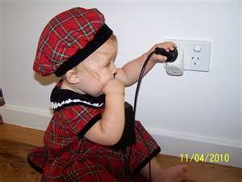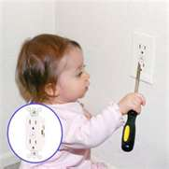

According to the US Consumer Product Safety Commission, more than 70% of these potentially fatal incidents occur in the presence of an adult. The most common foreign objects inserted into electrical outlets include the following:
- Hairpins/bobby pins (32%)
- Keys (17%)
- Fingers (12%)
- Pins, wires, screws, or nails (11%)
- Plugs (11%)
- Unidentified objects (8%)
- Paper clips or staples (5%)
- Tools such as tweezers, files, or knives (3%)
- Jewelry or belt buckles (1%)

The Electrical Safety Foundation International (ESFI) notes that many parents think they can address the electrocution risk by inserting plastic outlet caps into receptacles that fall within a baby or toddler's reach. However, an inquisitive baby can soon pry a cap loose and move on to "exploring" the receptacle.

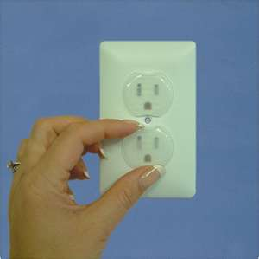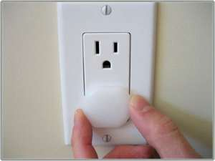

A safer solution is installing tamper-resistant outlets. These specialized outlets have been so effective in preventing injuries to children that the 2008 National Electrical Code requires that tamper resistant outlets be installed in all new homes constructed," says ESFI.

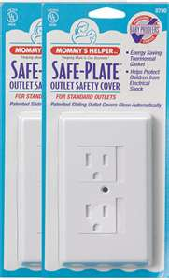

These devices are not expensive and can be retrofitted into older homes. They employ a spring-loaded shutter mechanism that only allows electricity to flow when equal pressure is applied simultaneously to both shutters (for example, when an electrical plug is inserted). During unused conditions, both shutters are closed and openings are covered.

Even the most careful parent or grandparent cannot watch a child every second. During those seconds when you aren't watching, tamper-resistant outlets can help cover for you.
Read more about tamper-resistant receptacles at
http://www.childoutletsafety.org/.

This information is provided to you by the IES Safety Committee

