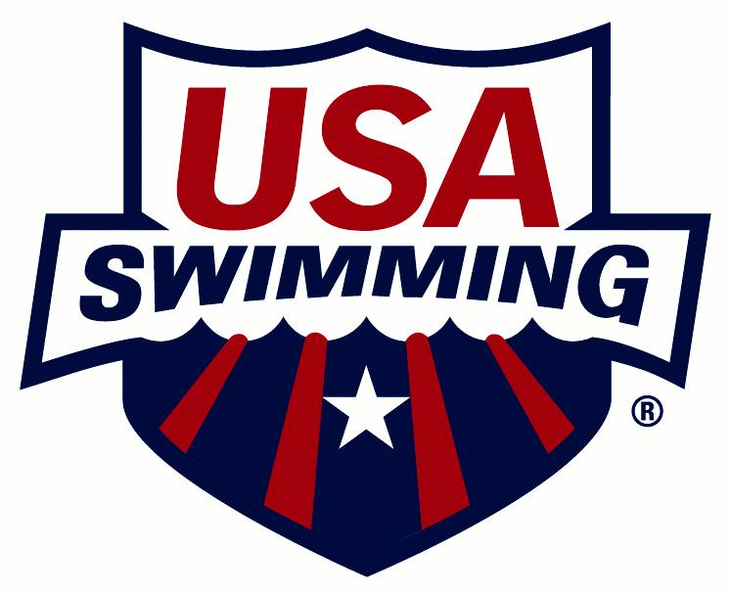

USA SWIMMING & INLAND EMPIRE SWIMMING

2020 CLUB APPLICATION

CLUB CODE: CLUB NAME:
NAME OF OWNER/BUSINESS/LEGAL ENTITY IF DIFFERENT FROM CLUB NAME:
1. 4.
2. 5.
3.
CLUB SETTING: □ Rural □ Suburban □ Urban
PLEASE CHECK ONE:
□ NEW CLUB □ RENEWING CLUB
(Club is defined as a group with athletes and coaches. Insurance certificate will be issued.)
FIRST YEAR AS A USA SWIMMING CLUB:
NEAREST MAJOR CITY: CLUB WEB SITE:
PRE-EMPLOYMENT SCREENING
□ By checking this box and signing below (e-signatures are acceptable), I formally acknowledge that this club is conducting a pre-employment screening on all new employees who are required to be members of USA Swimming as required in the USA Swimming Rules & Regulations, Article 502.6.8.
Signature: Date:
Failure to check this box and sign this statement will result in the club application being rejected.
RACING START CERTIFICATION
□ By checking this box and signing below (e-signatures are acceptable), I formally acknowledge that this club complies with all Racing Start Certification requirements as stated in the USA Swimming Rules & Regulations, Article 103.2.2 and maintains records for its athlete members.
Head Coach Signature: Date:
Failure to check this box and sign this statement will result in the club application being rejected.
STATE CONCUSSION LAWS
□ By checking this box and signing below (e-signatures are acceptable), I formally acknowledge that this club is following the state concussion laws regarding training coaches and providing educational information to athletes, parents, and guardians as required.
Signature: Date:
Failure to check this box and sign this statement will result in the club application being rejected.
MINOR ATHLETE ABUSE PREVENTION POLICY
□ By checking this box and signing below (e-signatures are acceptable), I formally acknowledge that this club is has implemented the USA Swimming Minor Athlete Abuse Prevention Policy, and require all athletes, parents, coaches and other non-athlete members of the club to review and agree to the Policy on an annual basis with such written agreement to be retained by the club.
Signature: Date:
Failure to check this box and sign this statement will result in the club application being rejected.
CLUB/MARKETING CONTACT/REPRESENTATIVE (This person will receive USA Swimming mailings and be responsible for distributing the information.)
CLUB/MARKETING CONTACT/REPRESENTATIVE:
POSITION (board president, owner, coach, etc.):
ADDRESS:
CITY: STATE: ZIP:
HOME PHONE: BUSINESS: MOBILE:
FAX: EMAIL:
PRIMARY ORGANIZATIONAL AFFILIATION, WHO OWNS THE CLUB, CLUB TAX LISTING (To register as a club, a selection must be made for Primary Organizational Affiliation, Who Owns the Club and Club Tax Listing.)
□ Check if registered last year and there are no changes to the Primary Organizational Affiliation, Who Owns the Club and Club Tax Listing that were listed last year.
PRIMARY ORGANIZATIONAL AFFILIATION
(Please note the club’s primary relationship/affiliation with any one of the following organizations. Choose one only.)

□Not Applicable
□Boys & Girls Club
□College/University
□Country Club
□Health & Fitness Club
□Hospital
□Jewish Community Center
□Park & Recreation Department
□Private School
□Public School/District
□Summer Club or Homeowner’s Association
□YMCA
□YWCA
□Other

WHO OWNS THE CLUB
□Not Applicable
□Boys & Girls Club
□College/University
□Country Club
□Health & Fitness Club
□Hospital

□Jewish Community Center
□Park & Recreation Department
□Private School
□Public School/District
□Summer Club or Home Owner’s Association
□YMCA
□YWCA
□Other

NAME OF COACH OWNER
**NAME OF COACH OWNER:
COACH’S USA SWIMMING ID#:
CLUB TAX LISTING
(Please list the club’s main tax listing and not the parent’s/booster organization if it is a separate entity.)

□Sole Proprietor
□Partnership
□LLC
□Sub-S Corporation
□Other For-Profit Corporation
□501(c)3 Non-Profit Corporation
□Other 501(c) Non-Profit
□Other Non-Profit Corporation
□Does Not Apply

LEARN TO SWIM PROGRAM
Does the club or coach own and operate a Learn to Swim Program? □ Yes □ No
If yes, is the club a current Make a Splash Local Partner? □ Yes □ No
If no, is the club associated with a Learn to Swim Program? □ Yes □ No
FIND-A-CLUB CONTACT (To register as a club, a Find-a-Club Contact must be listed. Information will appear on the Find-A-Club page of USA Swimming’s Web site.)
FIND-A-CLUB CONTACT:
PHONE: EMAIL:
REGISTRATION DATE AND TYPE
REGISTRATION DATE: (For LSC Office Use Only)
PLEASE CHECK ONE:
□ YEAR-ROUND CLUB □ SEASON 1 CLUB □ SEASON 2 CLUB
HEAD COACH
COACH:
ADDRESS:
CITY: STATE: ZIP:
HOME PHONE: BUSINESS: MOBILE:
FAX: EMAIL:

CLUB PRESIDENT
CLUB PRESIDENT:
ADDRESS:
CITY: STATE: ZIP:
HOME PHONE: BUSINESS: MOBILE:
FAX: EMAIL:
FACILITIES USED BY YOUR CLUB – LIST ALL FACILITIES (To register as a club, a facility must be listed. If additional space is needed to list facilities, use a separate sheet of paper and attach to the application.)
□ Check if registered last year and there are no changes to the facilities that were listed last year.
If a facility is no longer in use by the club, list the facility name and the word “Delete” (example: Nathan Natatorium – Delete).
FACILITY NAME:
ADDRESS:
CITY: STATE: ZIP:
POOLS AT THIS FACILITY:
Pool 1: Length: ______ □ Yards □ Meters Width: ______ □ Yards □ Meters □ Indoor □ Outdoor
# of Lanes: ______ # of Lanes: ______ □ L-shaped pool
Pool 2: Length: ______ □ Yards □ Meters Width: ______ □ Yards □ Meters □ Indoor □ Outdoor
# of Lanes: ______ # of Lanes: ______ □ L-shaped pool
FACILITY NAME:
ADDRESS:
CITY: STATE: ZIP:
POOLS AT THIS FACILITY:
Pool 1: Length: ______ □ Yards □ Meters Width: ______ □ Yards □ Meters □ Indoor □ Outdoor
# of Lanes: ______ # of Lanes: ______ □ L-shaped pool
Pool 2: Length: ______ □ Yards □ Meters Width: ______ □ Yards □ Meters □ Indoor □ Outdoor
# of Lanes: ______ # of Lanes: ______ □ L-shaped pool
FACILITY NAME:
ADDRESS:
CITY: STATE: ZIP:
POOLS AT THIS FACILITY:
Pool 1: Length: ______ □ Yards □ Meters Width: ______ □ Yards □ Meters □ Indoor □ Outdoor
# of Lanes: ______ # of Lanes: ______ □ L-shaped pool
Pool 2: Length: ______ □ Yards □ Meters Width: ______ □ Yards □ Meters □ Indoor □ Outdoor
# of Lanes: ______ # of Lanes: ______ □ L-shaped pool
FACILITY NAME:
ADDRESS:
CITY: STATE: ZIP:
POOLS AT THIS FACILITY:
Pool 1: Length: ______ □ Yards □ Meters Width: ______ □ Yards □ Meters □ Indoor □ Outdoor
# of Lanes: ______ # of Lanes: ______ □ L-shaped pool
Pool 2: Length: ______ □ Yards □ Meters Width: ______ □ Yards □ Meters □ Indoor □ Outdoor
# of Lanes: ______ # of Lanes: ______ □ L-shaped pool
If any of the above information changes, please notify your LSC Registration Chair.

