7-time Olympian Amanda Beard
is Coming to Elko!
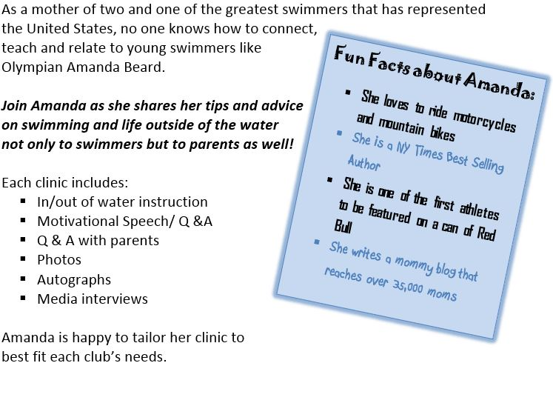
As part of her Swim Across America campaign, the Elko Swim Team will be holding a workshop hosted by 7-time Olympian Amanda Beard June 26^{th,}, 2015.

Schedule of events:
3:15PM -3:45pm Private Lesson
4:00PM-4:20pm Motivational speech
to Gold Swimmers (12-18 yrs)
and adults (masters
swimmers, triathletes)
4:30PM-6:00pm in/out of water instruction for
Gold Swimmers and Adults
6:10PM-7:00pm in/out of water instruction for all other swimmers (8-11 year olds)
7:05PM-7:20pm Q & A with parents
7:20PM-7:50pm Photos and autographs
7:50PM-8:00pm Interviews

Yes, you saw that – a private lesson will be auctioned off to ONE lucky winner! The auction will be held online beginning June 1st, so you don’t have to live in Elko to place a bid.

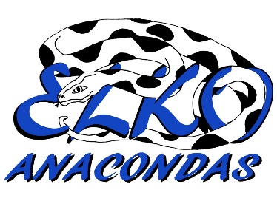
This workshop coincides with Elko’s High Altitude Swim Meet on June 27th and 28th, so mark your calendars. Look for more information about the Amanda Beard workshop and how to bid coming your way in early May. For questions, contact Michelle Smith at 775-934-5446 or elkoswimteam@gmail.com.

