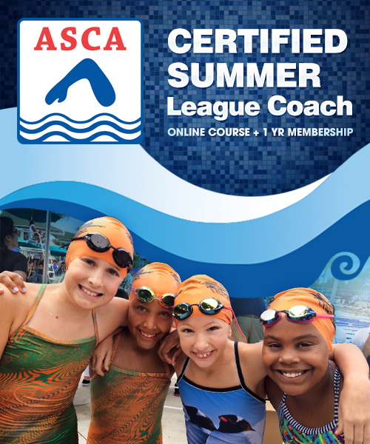
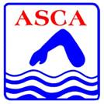

Utah Swimming & The American Swimming Coaches Association

- Summer League Certification (new from ASCA!)
- ASCA Level 2 – Stroke School
- Character First Presentation (given at ASCA World Clinic and USAS Convention)
Note: Level 1 can be achieved with the USA Swimming online 90-minute course for $15. Other requirements will also apply.

LOCATION, DATE & TIME
Both clinics (Summer League and Level 2) will be held on Saturday, May 23, 2015 at the Skaggs Catholic Center in Draper, UT. Coaches may attend one or both clinics. Times are as follows:
- ASCA Summer League Course: 6:00am – 12:00pm
- Putting Character First: 12:30-1:30
- ASCA Level 2 – Stroke School: 1:30pm – 8:30pm

Course Summary
ASCA Summer-League Course
The new ASCA Summer-League course is the first of its kind to educate and certify coaches specifically for summer-league coaching. Learn stroke technique, effective tips on managing meets, and have fun leading your swimmers to reach their fullest potential. As a bonus, a one-year full ASCA membership is included.

Putting Character First
This talk is will be a condensed presentation of the one given at the ASCA World Clinic and available on-line through ASCA.

ASCA Level 2 Stroke School
The Stroke School is about basics and fundamentals. It's about essential biomechanics and principles of swimming propulsion - not fads or new age sound bites. We cover novice through Olympian, but the emphasis is on the developmental swimmer. This is a great course for coaches of novice and developmental swimmers, or for head coaches looking for in-staff education ideas for their team.

SPEAKER: Don Heidary
ASCA Board Member, Senior Vice-Chair of Pacific Swimming, Head Coach/Founder of Orinda Aquatics
Don speaks regularly at the ASCA World Clinic on topics of age-group/club development and character/culture development. Orinda Aquatics is one of the top smaller clubs in the nation.

PRICING: Refer to the second page regarding pricing and registration options.

CONTACT: John Moran can be reached with any questions at johnmoran@skaggscatholiccenter.org.

PACKAGE OPTIONS & PRICES: All checks made out to Utah Swimming Coaches Association or USCA.

Session #1 ASCA Summer-League Course
Session #2 Putting Character First (this is offered complimentary with either session or by itself)
Session #3 ASCA Level 2 Stroke School

Package 1 |  | All 3 sessions |  | Non-members |  | $185.00
 |  |  |  | ASCA members |  | $110.00
Package 2 |  | Session #1 + #2 |  | Non-members |  | $100.00
 |  |  |  | ASCA members |  | $25.00
Package 3 |  | Session #2 + #3 |  | Non-members |  | $160.00
 |  |  |  | ASCA members |  | $85.00
Package 4 |  | Session #1 |  | Non-members |  | $100.00
 |  |  |  | ASCA members |  | $25.00
Package 5 |  | Session #3 |  | Non-members |  | $160.00
 |  |  |  | ASCA members |  | $85.00

*Non-member pricing includes a mandatory one-year membership fee of $70.00 to ASCA.

LUNCH: Add $15.00 to your payment if you would like your lunch catered.

