USA SWIMMING
COACH MEMBERSHIP REQUIREMENTS

From the USA Swimming rulebook: “Anyone who coaches athletes at a USA Swimming practice or competition must be a coach member of USA Swimming and must have satisfactorily completed safety training, criminal background check and other coaches’ education as required by USA Swimming.”

Requirements must be kept current at all times. There is no grace period; coach membership is not valid if any of the requirements lapse or expire. A coach does not have USA Swimming insurance coverage if his/her membership is not valid. To help coaches manage their membership requirements, the date that each requirement expires is printed on their USA Swimming coach membership card, as well as being available on the Deck Pass app and through the Club Portal. Additional information and links for each requirement can be found at www.usaswimming.org/coachmember.

Steps to become a coach member (additional details about each requirement are below):
- Initiate your criminal background check (www.usaswimming.org/backgroundcheck).
- Complete a CPR/AED course from the list below (courses not on the list will not be accepted).
- Complete Safety Training for Swim Coaches (details below).
- Determine your Local Swimming Committee (www.usaswimming.org/LSCmap) and then go to the LSC website to print the non-athlete application form.
- Send the completed form, payment, and your CPR/AED & STSC certifications to the LSC (amount due and address will be printed on the form)
- New members only: Receive email confirmation that your application has been received and entered into the database; then complete Steps 7 & 8.
- New members only: Complete Foundations of Coaching 101 (www.usaswimming.org/FOC).
- Complete the online Athlete Protection Training course (www.usaswimming.org/protect).

STEP 1: CRIMINAL BACKGROUND CHECK
All non-athlete members must pass a criminal background check every 24 months. Go to www.usaswimming.org/backgroundcheck for additional information and to initiate the background check. When the background check has been passed, your LSC is notified automatically. The cost of the initial background check is $36.50. The cost of the renewal is $18. If you don’t initiate the renewal within 30 days of your current background check expiration date, you will have to start over again and pay the $36.50.

STEP 2: ADULT & PEDIATRIC/CHILD CPR AND AED REQUIREMENT
Coach members must maintain a certification in Adult & Pediatric/Child CPR and AED. A list of acceptable certifications is at the end of this document. Certifications NOT on this list will not be accepted. Online-only courses are not acceptable. Coaches must submit a copy of their current CPR/AED cert to their LSC.

Coaches who do not have access to an acceptable CPR/AED course or have taken a course that is not on this list can call their local American Red Cross chapter to challenge one of their Adult and Pediatric CPR/AED courses. The challenge involves passing the skills assessment with an ARC instructor without having to take the entire course. The ARC will charge a fee for each challenge. Call your local ARC chapter to set up a challenge.

STEP 3: SAFETY TRAINING FOR SWIM COACHES (STSC)
The STSC requirement consists of two components: (A) an online course and test, and (B) an in-water skills session.

- All coaches must complete the online course and test.
- There are three options for completing the in-water skills session. Find the option that works best for you and then scroll down for additional information about that option:
STSC Option 1: Print the generic STSC In-Water Skills Checklist (available on your LSC website) and review the
skills with an instructor certified by one of the organizations on the checklist;
STSC Option 2: Maintain a valid lifeguard certification from an approved agency (list of approved agencies is below);
STSC Option 3: Take the full in-water skills session from an American Red Cross instructor.

To take the online component of Safety Training for Swim Coaches:

Mac users: You will need to use Mozilla Firefox as your browser in order to complete the online course and test. Other browsers, when using a Mac, may cause you to lose any record of having completed any part of the course.

The online component must be passed before taking the in-water skills component. Go directly to www.redcross.org/take-a-class and complete the steps below (a screen shot of this ARC web page is posted below).

Step one: Scroll down and click on “Swimming & Water Safety”. (See the screen shot below.)

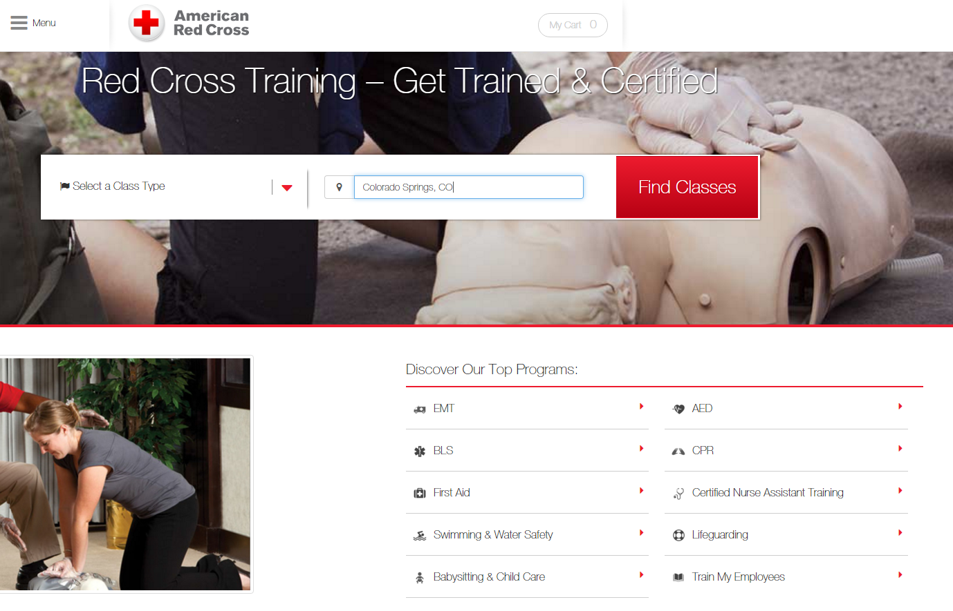

Step two: On the next screen scroll down to Safety Training for Swim Coaches. Click on “Find a Class”.

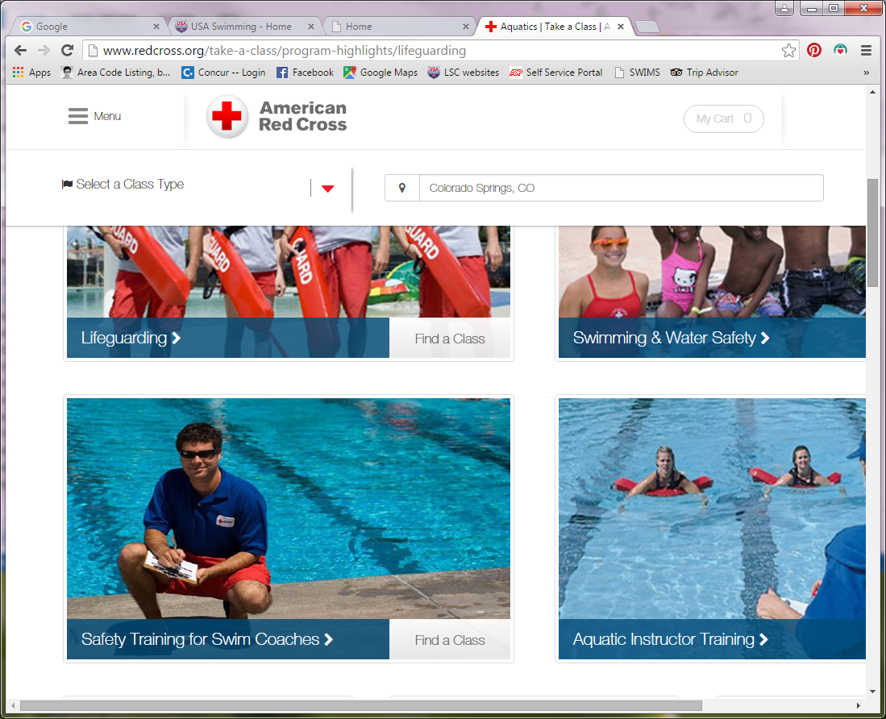

Step three: The next screen will display “Safety Training for Swim Coaches Online Content Only” - $19. Click on the large red square that reads “Take This Class”.

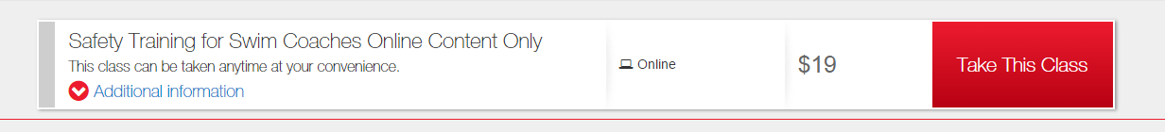

Step four: When the course is completed, save/print the Online Content Only certificate and forward it to your LSC registrar.

The course should take 2-3 hours to complete. Coaches can exit the course at any time and log back in to resume where they left off but once they start the final exam they need to complete it in one session.

To complete the in-water skills component of Safety Training for Swim Coaches (the online component of the course must be completed prior to the in-water component):

STSC OPTION 1: COACHES WHO USE THE GENERIC IN-WATER SKILLS CHECKLIST:
- Contact a lifeguard instructor certified by any of the organizations on the in-water skills checklist (sample checklist is below; a copy should also be posted on your LSC website). Set a time to review the skills in a pool with the instructor.
- Take a copy of the Online Content Only certificate and the in-water skills checklist to the pool for the skills review with the lifeguard instructor. Review the skills with the instructor, sign the checklist, have the instructor sign it, and then send both the checklist and online certificate to your LSC registrar. The earlier of the two expiration dates will determine the STSC credential expiration date.
- Repeat this procedure every two years.

STSC OPTION 2: COACHES WHO HAVE AN ACCEPTABLE LIFEGUARD CERTIFICATION:
- Obtain or renew an acceptable lifeguarding certificate (see the list below for acceptable certifications).
- Send an acceptable lifeguarding certificate and the STSC Online Content Only certificate to the LSC registrar. The earlier of the two expiration dates will determine the STSC credential expiration date.
- Repeat this procedure every two years.

STSC OPTION 3: COACHES WHO HAVE ACCESS TO AN AMERICAN RED CROSS INSTRUCTOR:
- Contact an ARC water safety, STSC or lifeguard instructor to schedule the ARC STSC in-water skills session in a pool with the instructor. (This session will be an abbreviated review session for those with a current STSC certification or a full session for those without a current STSC certification.) Coaches can also request a ‘blended learning’ course to include Adult and Pediatric CPR/AED, thus fulfilling another USA Swimming requirement at the same time.
- Take a copy of the Online Content Only certificate to the pool to prove you have passed the online course. Complete the in-water skills session with the ARC instructor, who will issue a STSC In-Water Skills Session certificate. Send both certificates to your LSC registrar. The earlier of the two expiration dates will determine the STSC credential expiration date.
- Repeat this procedure every two years.

To replace a missing or lost ARC certificate: www.redcross.org/getcertificates.

STEPS 4-5-6: APPLICATION FORM, SUBMITTAL INSTRUCTIONS, MEMBERSHIP CARD
Memberships are processed by each LSC (Local Swimming Committee). Non-athlete application forms can be found on most LSC websites. A map of LSCs and a list of their websites can be found at www.usaswimming.org/lscmap. If you cannot find the form online, please contact the LSC directly. Coaches should complete and mail their application, with payment, to the address printed on the application form. The membership fee is also printed on the form. Be sure to include a copy of your CPR/AED and STSC certifications. The LSC will mail the coach membership card after all membership requirements have been met. Coaches can check their membership status at any time on any mobile device through their Deck Pass account (www.usaswimming.org/deckpass).

STEP 7 (FOR NEW AND SECOND YEAR COACHES) THREE EDUCATIONAL REQUIREMENTS
- Foundations of Coaching 101: Foundations 101 must be completed prior to becoming a coach member of USA Swimming. ($15)
- Foundations of Coaching 201: Foundations 201 must be completed prior to 2nd year of registration. ($25)
- Rules and Regulations for Coaches Test: Rules and Regulations for Coaches must be completed prior to 2nd year of registration. (no fee)

Step 8: ATHLETE PROTECTION TRAINING
All non-athlete members must complete the online Athlete Protection Training course every 2-3 years (varies depending on the month the course is completed). The course takes approximately 60 minutes to complete and is offered at no charge. Go to www.usaswimming.org/protect for additional information and to access the course. When the course has been completed, the membership database is updated and the LSC is notified automatically.

New non-athlete members must register through their LSC first. New members cannot initiate the course until their membership application has been processed by their LSC. New members will receive an email as soon as their membership has been processed by the LSC. (An error message will appear during the log-in if the new member’s application hasn’t been processed yet.)

APPROVED CPR/AED CERTIFICATIONS

Requirements must be kept current at all times. There is no grace period; coach membership is not valid if any of the requirements lapse or expire. Coaches do not have USA Swimming insurance coverage if their membership is not valid; club insurance is also jeopardized by allowing coaches with lapsed certifications to be on deck. To help coaches manage their membership requirements, the date that each requirement expires is printed on the USA Swimming coach membership card, as well as being available on the Deck Pass app and through the online Club Portal. Below is a list of CPR/AED courses that have been approved by the Operational Risk Committee. Certifications from courses not on this list will not be accepted.

ORGANIZATION | COURSE NAME | NOTES RE THIS COURSE
American Red Cross  1-800-red-cross or support@redcrosstraining.org  NOT ACCEPTABLE:  - Instructor certifications  - First Aid, Health & Safety for Coaches  - Foreign Red Cross certs | Adult and Child CPR/AED
 | Adult and Pediatric CPR/AED
 | CPR/AED for Professional Rescuers and Healthcare Providers
 | Adult and Child First Aid/CPR/AED
 | Adult and Pediatric First Aid/CPR/AED
 | Responding to Emergencies
 | Lifeguarding/CPR/AED | Also acceptable for the STSC in-water skills requirement
 | Emergency Medical Response
 | Basic Life Support (BLS) for Healthcare Providers
 | Responding to Emergencies with CPR/AED – Adult and Pediatric
AAOS (American Academy of Orthopaedic Surgeons) | Healthcare Provider CPR/AED
American Heart Assoc. | ACLS Provider
 | Adult & Pediatric Basic Life Support | Two separate cards issued – one for Adult and one for Pediatric – both are required
 | Heartsaver CPR & AED | “Child CPR/AED” must be on the card.
 | Heartsaver First Aid with CPR & AED | “Child CPR/AED” must be on the card.
 | BLS for Healthcare Providers
 | HeartCode BLS
 | AHA Basic Life Support Instructor
 | AHA Instructor or Instructor Trainer | Applies to any of the AHA courses above
American Lifeguard Assoc. | Lifeguard, or Lifeguard Recert, with CPR/AED | Also acceptable for the STSC in-water skills requirement
ASHI (American Safety & Health Institute) | CPR and AED
 | CPR Pro
 | Basic Life Support
 | Pediatric CPR and AED | (The pediatric course does include adult CPR/AED)
 | Basic First Aid, CPR and AED
Boy Scouts of America | BSA Lifeguard | Also acceptable for the STSC in-water skills requirement
California Parks & Rec | California State Lifeguard
Ellis & Associates | International Lifeguard Training | One year certification;  Also acceptable for the STSC in-water skills requirement
 | Water Safety+
 | Int’l Lifeguard Training Instructor | Also acceptable for the STSC in-water skills requirement
EMS Safety Services | CPR/AED for Community Rescuers
 | CPR/AED for Professional Rescuers
 | CPR/AED & First Aid for Community Rescuers
EMT | Emergency Medical Technician Basic or Intermediate | The training agency for an EMT certification can be a hospital, fire department or other agency.
Emergency Care & Safety Institute | CPR and AED  (“Interactive” is NOT acceptable) | In conjunction with the American Academy of Orthopaedic Surgeons (AAOS may appear on card)
Life Safe Services | American Trauma Event Management Adult/Pediatric CPR/AED
Medic First Aid Int’l | First Aid Basic Plus
 | CarePlus CPR and AED
 | Pediatric Plus
NAUI (Nat’l Assoc of Underwater Instructors) | CPR & First Aid
National Safety Council | CPR & AED | Length of certification varies by training agency
 | First Aid, CPR & AED | Length of certification varies by training agency
 | Advanced First Aid, CPR & AED | Length of certification varies by training agency
 | Emergency Medical Response | Length of certification varies by training agency
Nat’l Registry of Emergency Medical Technicians | Paramedic
 | EMT – Basic or Intermediate
PADI Emergency First Response | CPR/AED – Adult  Care for Children – CPR/AED | Two different courses – one for Adult and one for Child – both certs are required.
ProCPR or ProTraining | Adult/Child/Infant CPR & AED for Health Care Provider (BLS)
 | ProFirst Aid/ProFirst Aid Advanced
StarGuard | StarGuard | Also acceptable for the STSC in-water skills requirement
Tacoma Fire Dept | First Aid, CPR & AED
 | Basic CPR – Adult & Child with AED
Save-A-Life Educators | CPR/AED – Adult/Child, or Adult/Child/Infant | Must include in-person skills assessment; if “online training” is printed on card, it must be accompanied by a second card stamped “skills assessment passed”.
 | CPR/AED/First Aid
University Training Centers | Healthcare Provider BLS – Level B or C

APPROVED STSC IN-WATER SKILLS CERTIFICATIONS

This list applies to the STSC in-water skills component only; all coaches are required to complete the STSC online course and test.

ORGANIZATION | COURSE NAME | NOTES RE THIS COURSE
American Red Cross  1-800-red-cross or support@redcrosstraining.org  NOT ACCEPTABLE:  - Instructor certifications  - Foreign Red Cross certs | Lifeguarding/CPR/AED | Also acceptable for the CPR/AED requirement
 | Lifeguarding
 | Lifeguarding Review
 | Shallow Water Lifeguarding
 | Extreme Shallow Water Lifeguarding
 | Aquatic Attraction Lifeguarding
 | Safety Training for Swim Coaches In-Water Skills Session
 | STSC In-Water Skills Checklist
American Lifeguard Assoc. | Lifeguard with CPR/AED | Also acceptable for the CPR/AED requirement
 | Lifeguard Recert with CPR/AED | Also acceptable for the CPR/AED requirement
 | STSC In-Water Skills Checklist
Boy Scouts of America | BSA Lifeguard | Also acceptable for the CPR/AED requirement
Ellis & Associates | International Lifeguard Training | One year certification; also acceptable for the CPR/AED requirement.
 | International Lifeguard Training Instructor | Also acceptable for the CPR/AED requirement
 | STSC In-Water Skills Checklist
International Life Saving Federation (ILS)  (Foreign certifications) | Pool Lifeguard | Only accredited certification from ILS member federations is acceptable. Visit http://ilsf.org/certification/equivalency-tables for a listing of countries with ILS accredited certifications.
StarGuard | StarGuard | Also acceptable for the CPR/AED requirement
 | STSC In-Water Skills Checklist
YMCA of the USA  NOT ACCEPTABLE:  - Instructor certifications  - Foreign certifications | Aquatic Safety Assistant (YASA) | 2016 version (v6) also acceptable
 | Lifeguarding | 2016 version (v6) also acceptable
 | Lifeguard Crossover | 2016 version (v6) also acceptable
 | STSC In-Water Skills Checklist

STILL HAVE QUESTIONS? Contact your Local Swimming Committee registrar.

Revised March 3, 2017

