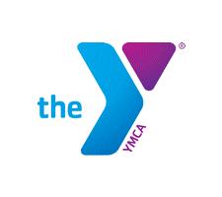
2020 YMCA National Gymnastics Championships
Graduating Senior Program Information Form

YMCA NAME: ______________________________________________________________

CITY/STATE: ______________________________________________________________

Fill out completely if you will be present and competing at the 2020 National Meet. Please submit a digital, wallet-sized senior picture with this form. All seniors will be featured in the meet program and will be recognized as part of the Special Graduating Senior Reception on June 23, 2020.

All information is due by May 1, 2020.

Please answer the following questions and submit with digital wallet sized picture
(minimum 300 dpi in jpeg or pdf format) with your registration information and email to: gymnationals@lbymca.org and sue.snead@lbymca.org

Please print clearly or type!

Gymnast: __________________________________________________________

Team Name: ________________________________________________________

Level: __________________ Years in YMCA Gymnastics: ____________________

Post-Graduation Plans/College Attending: _________________________________

25 words or less thanking those who have supported you ____________________

__________________________________________________________________

__________________________________________________________________

__________________________________________________________________

__________________________________________________________________

Due May 1, 2020
Late information cannot be accepted

Senior scholarship application forms are available on the meet website.

Return form to your Coach/Nationals Contact person and email copy with photo to:
gymnationals@lbymca.org and sue.snead@lbymca.org

