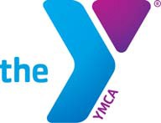
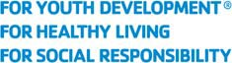
YMCA of the USA National Gymnastics Championship 2020 Outstanding Athlete Scholarship Award Application

Name

YMCA Affiliation Address

City State Zip

Phone ( )

Name of Gymnastics Coach

Phone ( )

Number of Years Participating in YMCA Gymnastics

Number of Years Competing in the YMCA National Gymnastics Championships

Name of High School Date of Graduation

Name of University/College applicant will be attending _____

Address ___City __State Zip __ ___

University/College Contact Person* __Phone (_ ) __

*Designated individual to ensure scholarship funds are applied to applicant’s tuition. Examples include admissions representatives and staff in the financial aid or bursar’s office.

Grade Point Average: Please attach unofficial academic transcript

Extracurricular/Volunteer Activities (OPTIONAL): Please attach resume or curriculum vitae (CV)

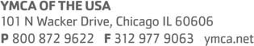

I understand that if I am selected as the recipient of the $1,000 YMCA of the USA National Gymnastics Championship Outstanding Athlete Scholarship Award, funds will be paid directly to the university or college in which I officially enroll (proof of enrollment must be submitted). If I decide to transfer to another school, the scholarship may be transferred upon approval of the YMCA of the USA National Gymnastics Advisory Committee. If, for any reason, I decide not to attend university or college the scholarship will be null and void.

Applicant’s Signature

Date

Parent’s/Guardian’s Signature

Date

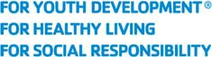

Please return completed application along with:
- Three letters of recommendation
- Reflection essay
- Unofficial academic transcript
- (Optional) Resume or curriculum vitae (CV)

Application must be submitted ELECTRONICALLY by May 1, 2020
to: Denice.Nugent@ymca.net

INCOMPLETE APPLICATIONS WILL NOT BE CONSIDERED

