2023 YMCA North Central Regional Short Course Swim Meet
Meet Announcement

Date: Fri-Sun March 17-21, 2023
Location: Wellmark YMCA
Entry Deadline: March 8, 2023
Hosted by: Iowa YMCA Swimming
Meet Director: Shelley Lechnir
shelley.lechnir@ymca-ywca.org
Web Site: www.iowaymcaswimming.org

Contents
About The Championship 2
Location and Facility 3
Web Site 3
Contact Information 3
NOTICES 4
Eligibility 4
Entry Information 6
Volunteers/Officials/Timers 7
Check-in Procedure 8
Championship Procedures and Operations 8
Awards and Recognition 11
Spectators 11
Liability, Safety and Emergency Procedures 12
Directions 14
Lodging 14
Parking 14
APPENDIX 1: Order of Events & Qualifying times 15
APPENDIX 2: YMCA Sanctioned Meet Declaration Form 17

About The Championship
This meet is a sanctioned, closed, inter-association championship YMCA meet. This meet and all participants will adhere to the Rules that Govern YMCA Competitive Sports and the Swimming Addendum to the Rules that Govern YMCA Competitive Sports. USA Swimming technical rules will be followed. The meet is YMCA sanctioned.
YMCA Sanction number: ()
ADJUSTMENTS TO THE MEET ANNOUCEMENTS: The Championship Meet Committee reserves the right to make any adjustments to the provisions of the meet announcement deemed necessary to ensure the fair and efficient running of the meet or due to unforeseen issues of weather or facility problems. Changes will be communicated as far in advance as possible. None of the required elements for a YMCA Sanctioned Championship and USA-S Approved meet can be changed.
COVID CONSIDERATIONS
DSMY and the Wellmark YMCA have taken enhanced health and safety measures – for you, our other guests, volunteers, and our athletes. You must follow all posted instructions while inside any of the Greater Des Moines YMCA facilities. An inherent risk of exposure to COVID-19 exists in any public place where people are present. COVID-19 is an extremely contagious virus that can lead to severe illness and death. According to the Centers for Disease Control and Prevention, individuals with underlying medical conditions are especially vulnerable to COVID-19. You and your athletes are voluntarily assuming all risks related to exposure to COVID-19.
COVID-19 team protocols may be in place for this meet including but not limited to: separate pool entrance and exit, member screening questions, social distancing, face masks, limited locker room access (swimmers are recommended to arrive and leave in swim attire), personal space on the pool deck, and designated lanes for warm-ups.

All swimmers, coaches, and meet volunteers must enter the building using the lower-level Grand Avenue entrance. Spectator seating will open at each session’s warm-up start time and will enter on the second level skywalk entrance to the pool.
MEET TIMELINE: Warm-up and start times for all sessions are subject to change depending on the size of the meet.

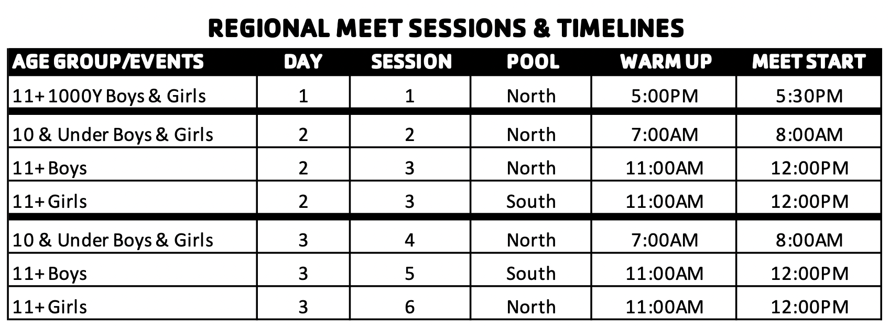
5

INCLEMENT WEATHER/CANCELATION: The safety of all participants is our number one priority. In the event of dangerous weather the committee will convene to determine a course of action for the meet. This information will be communicated to coaches via email and posted on the Regional YMCA website.

Location and Facility

Location: MidAmerican Energy Company Aquatic Center, Wellmark YMCA

Emergency Phone Number: 515-282-9622

The Prairie Meadows Pool (competition pool) is a 20 lane 25-yard short course pool with 1 moveable bulkhead allowing for an 8 lane 50-meter long course pool or multiple configurations when running short course competition(s). Water depth of the pool ranges from 10 feet 8 inches to 7 feet (minimum 5 feet required at start end). Lane width is 8 feet 3 inches. Colorado electronic timing systems will be used in all configurations. Pool configurations and the number of courses will be determined once entries have been received. The 4 lane 25-yard program pool will be made available for warm-up and cooldown when running two pools. The competition courses have been certified in accordance with 104.2.2C (4) of USA

Swimming Rules and Regulations. A copy of the certification is on file with USA Swimming.

The MidAmerican Energy Company Aquatic Center provides seating for 1200 spectators. Seating MAY be limited depending on covid guidelines set forth from the YMCA/City/State/Federal entities.

Free wi-fi is available throughout the natatorium.

Permanent on-deck seating for up to 300 athletes plus additional temporary bleachers as needed.

Web Site
Meet Information can be found at: www.teamunify.com/ymcanc
Online Meet Results: Meet Mobile results will be posted throughout the meet.
The meet will be livestreamed at www.dsmytv.com

Contact Information
YUSA Regional Rep. Donald Pirrie iowayswimming@gmail.com
Meet Director: Shelley Lechnir shelley.lechnir@ymca-ywca.org
Entry Chairperson: Donald Pirrie iowayswimming@gmail.com
Meet Referee: Dee Norton dee.norton@mchsi.com
Admin Official: TBD
Officials Coordinator: Dee Norton dee.norton@mchsi.com
Safety Director: Lindsey Phelps lindsey.phelps@dmymca.org
Aquatic Events Director John VanMeter john.vanmeter@dmymca.org

NOTICES

USA Swimming Statements:

• The competition course has been certified in accordance with 104.2.2c(4). A copy of such certification is on file with USA Swimming.

• Water depth of the pool ranges from 10 feet 8 Inches to 7 feet.

• Deck changes are prohibited

• Use of audio or visual recording devices, including cell phones, is not permitted at any time in changing areas, restrooms, or locker rooms.

• Swimmers ages twelve years and younger are prohibited from wearing "Tech" suits, even when swimming in Senior or Open events or time trials. A list of suits that are considered "Tech" suits is posted on the USA Swimming website.

• All applicable adults participating in or associated with this meet, acknowledge that they are subject to the provisions of the USA Swimming Minor Athlete Abuse Prevention Policy (“MAAPP”), and that they understand that compliance with the MAAPP policy is a condition of participation in the conduct of this competition.

• In granting this approval, it is understood and agreed that USA Swimming and IASI shall be free and held harmless from any liabilities or claims for damages arising by reason of injuries to anyone during conduct of the event.

Eligibility
ATHLETE
YMCA Membership: An athlete must be a YMCA member in good standing who holds an annual, full privilege membership at the YMCA he/she represents for a period of at least 90 days prior to the first day of the meet. An athlete may have only represented that YMCA team in competition for a period of 90 days prior to the first day of the meet, excluding scholastic competition.
Amateur Status: An athlete may not have represented a college, university or other post-high school institution in any competition and may not have accepted pay or compensation for competing as a swimmer.
Unattached Athletes: There is no unattached status in YMCA Swimming.
Age: Swimmers cannot swim in more than one session per day.
YMCA Meet Participation: In order to be eligible to compete, each athlete must have competed in a minimum of 3 closed YMCA inter-association meets since September 1, 2022.
Times: An athlete must achieve the minimum qualifying time standard for each event in which he/she enters during the period from March 1, 2022 to the entry deadline.
Athletes with a Disability: Swimmers with a disability are welcome to enter this meet. The coach or team entry person must alert the meet director and the meet referee as to the need for any special accommodations or seeding arrangements at the time the entry is submitted. If modifications to USA Swimming rules are necessary, then the coach or athlete must notify the meet referee of any disability prior to competition.

COACH
Required Certifications: Coaches must hold current certifications in the following courses in order to receive a deck credential: Professional Rescuer CPR, First Aid, Safety Training for Swim Coaches (a Lifeguard certification may be used if accompanied by completion of the Safety Training for Swim Coaches online content), APT Training and Principles of YMCA Competitive Swimming and Diving. A list of the acceptable certifications can be found in the Swimming Addendum to the Rules That Govern Competitive Sport.
Coach Registration: Each coach must have completed the annual YMCA on-line coach registration process. Coaches who are not registered and approved will not be permitted on deck.
Teams without A Coach at the Meet: All athletes and teams must have at least one certified and credentialed YMCA coach designated as being responsible for their supervision during competition. When a YMCA team will not have a coach present, that YMCA may authorize an eligible coach from another YMCA attending the meet to be responsible for their athletes at the meet. The Meet Director and Meet Referee must be notified of this situation.

TEAM
Team Registration: Each team must have completed the annual YMCA on-line team registration and paid the annual registration fee.
Insurance: Each team that participates in the meet must have a current and correct Certificate of Liability Insurance, in effect through the last day of the meet.

Entry Information
ENTRY LIMITS: Each swimmer may enter a total maximum of seven individual events. Swimmers may only swim in one session per day. Entries will be accepted into the meet in the order they are received. Entries will begin to be accepted at 10:00am on March 8, 2023 from teams in the North Central region. All other regions may submit entries at 10:00am on Thurs March 11. Entries received before this date and time will be rejected.
QUALIFICATION PERIOD: The qualification period is March 1, 2022 through the entry deadline.
USA-S IDs: Only USA-S registered athletes should have an ID number in the Meet Entry File.
TIME STANDARDS: Swimmers must have equaled or bettered the minimum time standard: Appendix 1.
TIMES: No Times (NT) are not allowed. Entered times must be the swimmer’s BEST time achieved during the qualifying period.
ENTRY FEES: There is a flat fee of $35 per swimmer to enter the meet. There are no per-event fees. Payment should be in the form of a check made out to “Iowa YMCA Swimming”
Note: If your payment has not been received by the deadline, your swimmers will be removed from the meet.
All coaches are expected to model the YMCA Core Values in all aspects of the meet, including team registration, submission of entries, and the meet itself. Anyone found having falsified information about the eligibility of a swimmer, or to have altered any official document (including meet results), may along with their team, be subject to severe disciplinary action. The offending team’s Executive Director will be notified promptly and asked to help resolve such issues.
ENTRY DEADLINE: Entries must be submitted by midnight on March 12, 2023

ENTRY PROCEDURE: To submit your entries using HY-TEK Team Manager, go to the Regional YMCA Swimming Website to, download the event file, and import it into Team Manager.
Once you have imported this file, DO NOT MODIFY THE EVENTS IN ANY WAY! Doing so may cause your entries to be rejected.
Complete your entries, export them, and send the exported file to yregionalentries@gmail.com
Note: A time standard file is also available on the web site. You can import this file into both Team Manager and Meet Manager so that qualifying times can be automatically flagged when you print reports.
If you do not have Team Manager, you may submit your entries in readable form as a document attached to an email.
For each swimmer, be sure to provide their name, gender, date of birth, event numbers, and qualifying times. Note that a handling fee of $10 per swimmer will be assessed.
Your entries must be accompanied by your Team Registration Form, found at the end of this handbook. Send your entries and the form to the Entry Coordinator, using the address or email address above
PAYMENT: Once a team’s entries have been accepted by the meet host, the team is considered entered into the meet. A team entering the meet is responsible for entry fees for all swimmers entered into the meet. Changes or scratches in a team’s entries prior to or after the meet entry deadline do not relieve a team of their responsibility to pay for confirmed entries.
Payment must be received by March 14, 2023. Payment should be made out to Iowa YMCA Swimming and mailed to Donald Pirrie, 1614 West Mount Vernon Road, Mount Vernon, IA 52314

Volunteers/Officials/Timers
OFFICIALS AND TIMERS: We will need many officials, both Level 1 and Level 2 to properly run a meet of this size. If you have a current YMCA or USA Swimming certification, you are strongly encouraged to officiate at this meet.
In order to ensure consistent officiating please work as many sessions as possible – at least two over the course of the weekend will be the expectation.
SIGN-UP PROCEDURE: Please contact Dee Norton at dee.norton@mchsi.com to sign-up to officiate at this meet.
ATTIRE: Please bring your white shirts and navy shorts or pants and your Officials patch. You will not be allowed on the pool deck without your patch.

Check-in Procedure
MEET CHECK-IN PROCEDURE: All coaches and deck officials must check in. Check in will be at the pool entrance. After checking in the Head Coach will receive their team packet, Championship Deck Pass and scratch sheet at the check-in table. Deck passes must be worn and visible at all times when on deck.
EVENT CHECK-IN: Positive check in for the 500Y and 1000Y events will be required at the start of the session.
COACHES MEETING/SCRATCH MEETING: The coaches meeting will be held in the wet classroom on the pool deck at 7:00am on SAT AM. If needed, a Sunday AM coaches meeting will also be held.
OFFICIALS AND TIMERS MEETING: The timers meeting will be held on the south side of the natatorium (behind admin desk) 20 minutes prior to the start of each session.

Championship Procedures and Operations
CHAMPIONSHIP COMMITTEE: The Committee will consist of the Meet Director, Meet Referee, Regional Rep and a coach from two separate teams.
RULES: The meet will run under YMCA Rules that Govern Competitive Sports, Swimming Addendum to the YMCA Rules that Govern Competitive Sports, USA-S Technical Rules.
MEET FORMAT: The meet will be swum using a timed finals format. Swimmer’s age will be determined as of December 1, 2022
FLYOVER STARTS: Flyover starts will be used. Swimmers are to report to the starting blocks. 10u swimmers will report to the ready wall.
EVENT SEEDING: Events will be seeded Slowest to Fastest. The Meet Referee/Administrative Official reserve the right to combine heats.
SCRATCH PROCEDURES: An athlete is considered entered into an event unless he/she scratches from that event. If an athlete does not scratch from an event and does not swim the event, that event still counts toward the athlete’s total number of events for the meet.
DECLARED FALSE START: An athlete may also withdraw from a heat or swim-off by electing to take a declared false start. Such declaration must be made known to the Deck Referee before the heat or swim off is announced. A declared false start counts as an event swum for the athlete and will be counted in the maximum number of events allowed for each athlete.
NO SHOW: An athlete who is seeded in an event and fails to compete (i.e., a “no show”) shall not compete in any further individual or relay events unless the athlete and/or coach declares an intent to swim to the Administrative Referee prior to the next scheduled event for the athlete.

WARM-UP SAFETY PROCEDURES: Prior to warm-ups, teams will be advised of the current warm up procedure in place for the meet. Teams will be assigned a pool and lane. Starts may be conducted during the last 10 minutes of each warm up period. Start lanes will be announced by the referee.
Once the pool is cleared or we have reached the maximum warm-up time for the session, the pool will be cleared for 10 minutes.
All swimmers must be under the supervision of a certified coach from their respective team during warm-up, competition, and warm-down. Facility rules require a 3 point, feet first, sit and slide entry for lanes designated for circle swim during warm-up and warm-down. Entry and exit instructions will be given by supervising coach.
SWIM-OFFS: In the event a swim-off is necessary, the meet referee will set a time for the swim-off which will not be any later than 45 minutes after the last heat of any event in which any of the swimmers in the swim-off is competing. (USA Swimming Rule 102.5.2)
RESULTS: Any results displayed on the scoreboard are unofficial until final results are published. Results will be posted on Meet Mobile.
PROTEST PROCEDURE: Protests may only be initiated by a person with standing, that is, a coach or YMCA supervisor whose team is competing in the meet. The Championship committee will arbitrate protests, eligibility issues, safety rules and other issues
Protests against the judgment decisions of starters, stroke, turn, place and relay take-off judges can only be considered by the Referee and the Referee’s decisions will be final USA-S Rule 102.23).

CONDUCT AND RESTRICTIONS: The Meet Referee reserves the right to dismiss any swimmer, coach and/or spectator from the competition due to inappropriate conduct
- Deck Changes are prohibited. The USA Swimming Rulebook defines Deck Change as: Changing, in whole or in part, into or out of a swimsuit (excluding a drag suit) in an area other than a permanent or temporary locker room, bathroom, changing room or other space designated for changing purposes while at a practice, competition, or other pool-related activity.” This includes slipping off the top of a one-piece performance suit to place on an alternate bikini top immediately following a race.
- Swimmers ages 12 years and younger shall not compete while wearing a ‘tech suit’, even when swimming in an open/senior event.
- Glass, Food, and Chairs are not permitted on deck.
- Deck access is limited to swimmers, certified coaches, officials, meet personnel and volunteers only.
- The use of audio or visual recording devices, including a cell phone, is not permitted in changing areas, rest rooms or locker rooms.
- Photographs are not allowed to be taken behind the block during competition. No flash photography allowed at the start of each event.
- Massage tables are not permitted.
- Individuals are responsible for the security of their personal belongings and are encouraged not to bring valuables to the meet venue and not to leave items unattended.
- Operation of a drone or any other flying apparatus, is prohibited over the venue (pools, athlete/coach areas, spectator areas and open ceiling locker rooms) any time athletes, coaches, officials and/or spectators are present.

Awards and Recognition
SCORING: All events will be scored to 16 places as follows:
Individual events: 20-17-16-15-14-13-12-11-9-7-6-5-4-3-2-1
Relay events: 40-34-32-30-28-26-24-22-18-14-10-8-6-4-2
AWARDS: Medals will be awarded for places 1-3, rosettes for places 4-8 and ribbons for places 9-16 including relays.

RECOGNITIONS:
A High Point Trophy will be awarded to the Highest scoring swimmer and runner up in each of the following age groups: 8&U, 9-10, 11-12, 13-14, 15&O. High Point trophies will be awarded at the conclusion of the Sunday Sessions for each age group. Relays do not count toward individual high point scores.
At the conclusion of the meet, team banners will be awarded for teams placing 1st through 3rd in total team points.

Spectators
ADMISSION FEE: There is no fee for admission.
HEAT SHEETS/PROGRAMS: Will be for sale at the upper entrance of the spectator seating area.
CONCESSION STAND: A concession stand will be provided by meet volunteers and will be available during the meet in the upper spectator balcony.
ATHLETE APPAREL: Elsmore Swim Shop will be on-site and will have a variety of swimwear and accessories for sale. Fine Designs will be onsite with a selection of Meet Apparel for sale.
SEAT SAVING POLICY: The saving of seats is not permitted in the natatorium. Please be courteous of all spectators keeping in mind the core values of the YMCA.

CONDUCT AND RESTRICTIONS:
- No personal chairs are allowed in the spectator area or on deck.
- Parents are responsible for the conduct of their children. Children are not allowed to roam the facility unattended.
- The use of audio or visual recording devices, including a cell phone, is not permitted in changing areas, rest rooms or locker rooms.
- Spectators are not permitted on deck.
- No smoking, drugs, or alcohol are permitted in the swimming complex.
- Glass containers of any kind are not permitted on the pool deck or in the spectator seating area at any time.

Liability, Safety and Emergency Procedures
INSURANCE: Each Association participating in this meet must have insurance coverage for representative(s) including leadership and participants who will be in attendance for the period of the meet. Appendix 3 must be signed by each association participating in the meet.
LIABILITY LIMITS:
- In granting of the USA-S/IA approval, it is understood and agreed that USA Swimming and IA-LSC shall be free and held harmless from any liabilities or claims for damages arising by reason of injuries to anyone during the conduct of the meet.
- In granting the YMCA Sanctioning, it is understood and agreed that YMCA of the USA shall be free and held harmless from any liabilities or claims for damages arising by reason of injuries to anyone during the conduct of the meet.
- It is understood and agreed that USA Swimming and IASI shall be free and held harmless from any liabilities or claims for damages arising by reason of injuries to anyone during the conduct of the event.

- USA Swimming, Inc., IASI and DSMY cannot prevent you and your athlete from becoming exposed to, contracting, or spreading COVID-19 while participating in USA Swimming and IASI sanctioned events. It is not possible to prevent against the presence of the virus. Therefore, if you choose to participate in a USA Swimming or IASI sanctioned event, you may be exposing yourself and your athlete to and increasing you and your athlete’s risk of contracting or spreading COVID-19.
BY ATTENDING OR PARTICIPATING IN THE COMPETITION, YOU VOLUNTARILY ASSUME ALL RISKS ASSOCIATED WITH EXPOSURE TO COVID-19 AND FOREVER RELEASE AND HOLD HARMLESS USA SWIMMING, IOWA SWIMMING, INC., AND DSMY AND EACH OF THEIR OFFICERS, DIRECTORS, AGENTS, EMPLOYEES OR OTHER REPRESENTATIVES FROM ANY LIABILITY OR CLAIMS INCLUBING FOR PERSONAL INJURIES, DEATH, DISEASE OR PROPERTY LOSSES, OR ANY OTHER LOSS, INCLUDING BUT NOT LIMITED TO CLAIMS OF NEGLIGENCE AND GIVE UP ANY CLAIMS YOU MAY HAVE TO SEEK DAMAGES, WHETHER KNOWN OR UNKNOWN, FORESEEN OR UNFORSEEN, IN CONNECTION WITH EXPOSURE, INFECTION, AND SPREAD OF COVID-19 RELATED TO PARTICIPATION IN THIS COMPETITION.

EMERGENCIES: the facility personnel will handle all emergencies at the meet. These individuals will provide CPR and first aid as needed and will ensure that individuals with serious injuries are transported immediately to the nearest hospital for further treatment. Defibrillators will be on site.
Any coach, athlete or official who recognizes an emergency situation should immediately inform the facility’s personnel and then make sure the vicinity of the emergency is clear for the emergency personnel to do their job.
UNACCOMPANIED ATHLETE: Each athlete must have a certified coach responsible for him/her while on the pool deck. The coach of the athlete must authorize in writing a coach from another team to represent their team and be responsible for the swimmer(s).
CONCUSSION AWARENESS: This meet will follow the YMCA of USA Concussion procedure. Anyone who observes or has knowledge of a potential head injury should immediately notify lifeguards and/or hired medical personnel. Once the injury report is completed, the lifeguard and/or hired medical personnel will notify the Event Staff, the athlete’s coaching staff, and the Meet Director.
If a head injury occurs, the action plan below will be followed:
- Athlete is removed immediately from participation by the Meet Director
- Athlete must be evaluated by a licensed health care professional experienced in identifying and treating concussions. In addition, the athlete must be in compliance with the laws that are in effect within the jurisdiction where the meet is held.
- The coaching staff will inform the athlete’s parents or guardians about the possible concussion and give or send them the fact sheet on concussion.
- The athlete will not be allowed back to warm-up or compete until a health care professional, experienced in evaluating concussions determines that the athlete is symptom-free and is OK to return to participation.
LIGHTNING POLICY: The National Lightning Safety Institute, National Athletic Trainers Association, American College of Emergency Physicians, USA Swimming, and YMCA of the USA all recommend or require closing an indoor pool during an electrical storm. This policy will be followed at the meet.
EVACUATION PROCEDURE: Facility personnel will direct swimmers, coaches, and spectators to the appropriate locations in the event of a facility evacuation.

Directions
The Wellmark YMCA is located at 501 Grand Avenue, Des Moines, IA 50309
Link to Google Maps: https://tinyurl.com/y8wylhpv

Lodging
There are many hotel options available in the city including several downtown locations near the Wellmark YMCA. Hotel options with block rooms saved for the meet include the Downtown Hilton. This hotel is directly connected to the Wellmark YMCA via the City Skywalk System.
Booking and updated hotel information can be found on the Regional Meet Page on our website: https://www.teamunify.com/Home.jsp?team=ymcanc

Parking
There are more than 30,000 parking spots throughout the city.
Find resources at: catchdesmoines.com/about/transportation/parking

Metered Parking is available Mon-Sat 9am-9am
Parking is free on Sunday

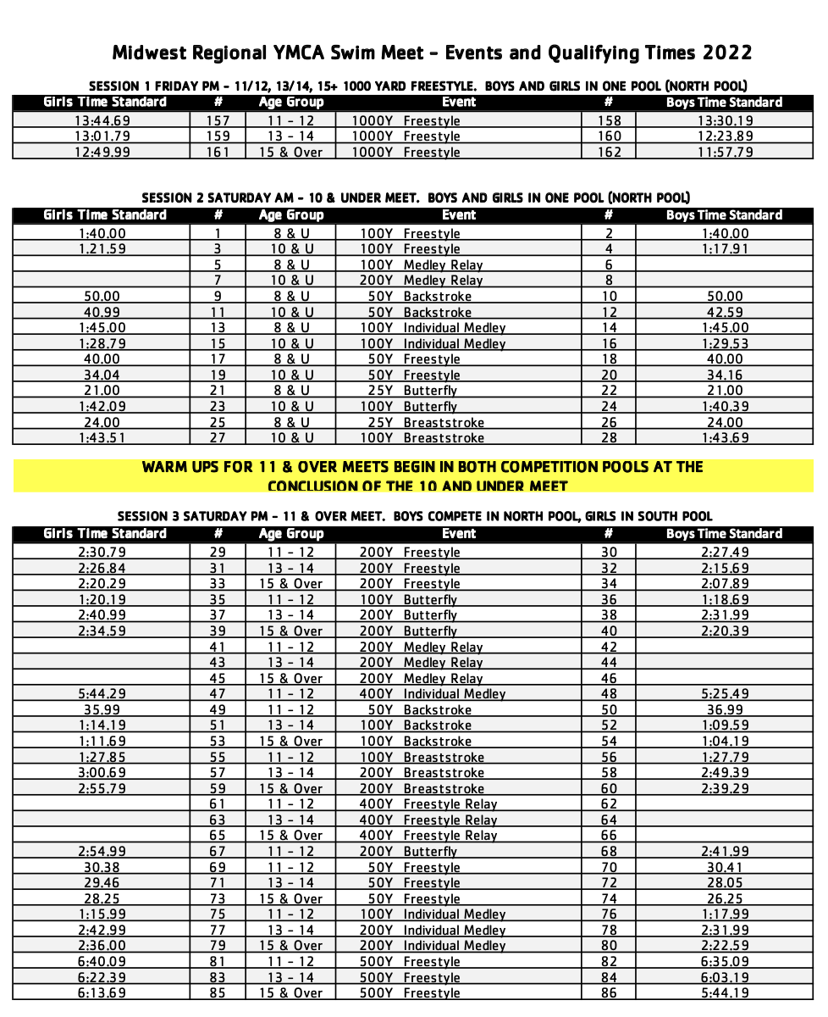
APPENDIX 1: Order of Events & Qualifying times

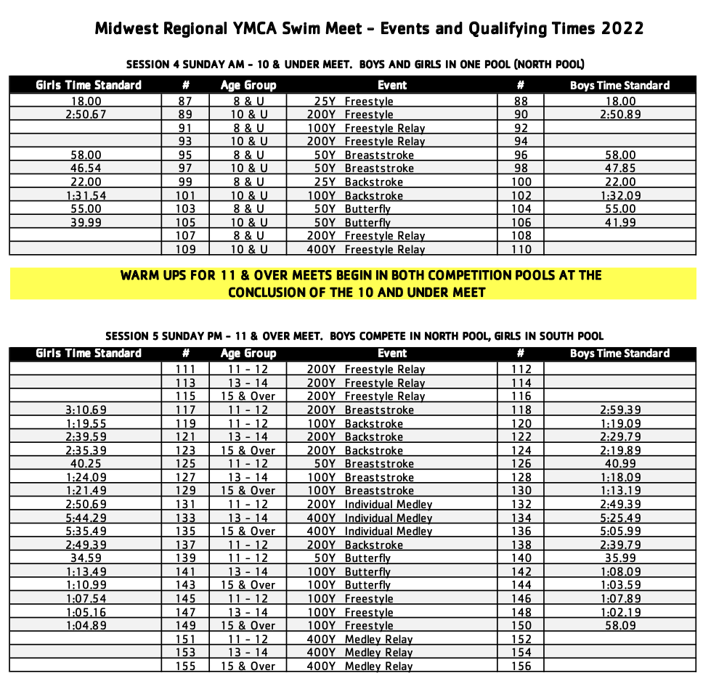

YMCA Sanctioned Meet Declaration Form
(Return signed form to the meet director)

Participating YMCA: ___________________________________________________________
YMCA Address: _______________________________________________________________
Meet Name: 2023 North Central Regional Championship Swim Meet
Meet Date(s): 03/17/23 – 03/19/23
Meet Host: Iowa YMCA Swimming League
Meet Location: Wellmark YMCA, 501 Grand Avenue, Des Moines, IA. 50309
-------------------------------------------------------------------------------------------------------------
We the undersigned attest to the following:
SWIMMERS - All swimmers representing the YMCA above are full privilege members of the YMCA and meet all eligibility requirements. All swimmers age 18 and older have completed Child/Athlete Protection Training within the past 12 months.
COACHES - All coaches representing the YMCA above hold current certifications in BLS (Professional Rescuer CPR), First Aid, Safety Training for Swim Coaches, Child/Athlete Protection Training and Principles of YMCA Competitive Swimming and Diving and have completed the annual YMCA coach registration online.
INSURANCE - Our Association now has insurance coverage for representative(s) including participants, coaches, volunteers and leadership who will be in attendance at the 2023 North Central Regional Championship Swim Meet for the entire period of the meet. I hereby certify that YMCA has a minimum of $1,000,000/$2,000,000 in liability insurance that covers our participants, coaches, volunteers and leadership during their participation in the 2023 North Central Regional Championship Swim Meet.
RELEASE - In consideration of your accepting this entry, I hereby, for myself, heirs, executor and administrators, waive and release any and all right and claim for damages I may have against the YMCA of the USA, the Iowa YMCA Swimming League, their agents, representatives or assigns, and the Greater Des Moines YMCA for any and all injuries which may be suffered by participants at the 2023 North Central Regional Championship Swim Meet. Furthermore we understand that the YMCA of the USA and the Iowa YMCA Swimming League are not responsible for any intended or unintended consequences related to removing an athlete from competition for a head injury. This includes, but is not limited to, any financial reimbursement associated with such removal.
____________________________ ________________________________
Name and Signature of Head Coach
____________________________ ________________________________
Name and Signature of YMCA Executive Director or Designee

This is the last page of the Meet Announcement

