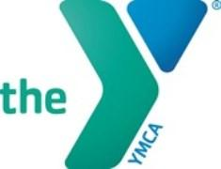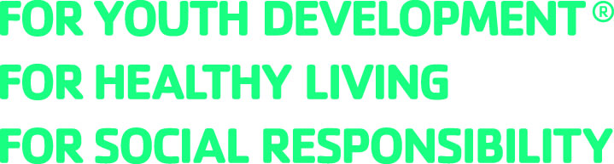

YMCA of the North Shore
JOB DESCRIPTION

TITLE: Sr. Aquatics Director
CLASSIFICATION: Full Time Exempt
DEPARTMENT: Aquatics/Competitive Aquatics
REPORTS TO: Director of Operations and Senior Director of Competitive Aquatics and Head Coach

POSITION SUMMARY
The Sr. Aquatics Director is responsible for all aspects of the recreational and competitive aquatics experience. The role develops, implements, manages and evaluates all aquatics and competitive aquatics programs. Key to this role is recruiting, retaining and transitioning swimmers of all ages and abilities through the programs and achieving a successful conversion rate of swimmers to the competitive program. Through strong leadership, dynamic planning, high quality engagement, and direct service, the Sr. Aquatics Director manages an excellent staff team, provides guidance on the technical and physical skills of swimming, helps coordinate and participate in swim meets (both home and away), creates an environment of fun that develops relationships, achievement and belonging while fostering a lifelong love of swimming and the water.

ESSENTIAL FUNCTIONS
- Recruit, hire, train, develop and manage high quality staff for all components of the department. Ensure records of staff certifications are up-to-date and complete.
- Create and lead a culture that provides an excellent participant experience by leading quality programs and services, including but not limited to, aquatics classes, competitive practices and workouts, aquatic open times, vacation programs, and special events. Lead site specific events and assist in association wide swim team social event planning, as necessary.
- Develop and Lead structured swim team practices focusing on stroke technique, competition preparedness, relationship building and collaboration based on the YNS competitive swim schedule.
- Implement association swim lesson curriculum providing progression to the aquatics program. Assist in creating thorough, age-appropriate swim team and masters swim workouts focusing on technique, endurance, stroke development, drills, etc.
- Assist in coordinating and executing swim team competitions and meet registrations. Record times at swim meets.
- Manage all reporting relative to programming, activities and pool operation management. Keep detailed and accurate records as needed including attendance, work-outs and swimmer progression, maintenance logs, etc. Manage and maintain all pool operation and programming equipment.
- Maintain consistent, clear, effective and positive communication with youth and parents. Personally build relationships with YMCA members through daily interactions.
- Foster and maintain positive relationships with schools, agencies and organizations to expand services, programs and the impact of the Y in the community. Be proactive and flexible in addressing community needs for aquatics programming.
- Establish and innovate new programs and scheduling to increase and improve the quality of programming and quantity of registrants.
- Ensure optimal program availability, safety and cleanliness by adhering to all safety guidelines for pool and aquatics operations according to local, state, YMCA and Risk Management guidelines and regulations. Provide support for and direct leadership of outdoor pools and guards as applicable.
- Participate in the development of marketing efforts for aquatics programming.
- Act as an engaged and participative member of the local Y and its operations. Attend, on an as needed basis, staff meetings, trainings and swim team events including meets, and social events. Participate in annual YMCA fundraising and site wide special events.
- Remain up to date regarding YMCA and aquatics trends nationally as well as emerging YMCA trends within aquatic programming and advocate for the expansion of Y programs and services aligned with those trends.
- All other duties as directed or required for the overall success of the organization.

QUALIFICATIONS
- Bachelor's degree or commensurate work experience.
- At least 21 years of age with 3-5 years experience as a competitive coach, preferably in a leadership capacity.
- Current USA Swimming and or YMCA Swim coach credentials. Certified Pool Operator CPO, CPR, AED, Basic First Aid certification or ability to obtain within 3 months.
- Must be able to demonstrate proficiency of swim skills in accordance with YMCA standards and have a strong foundation in stroke mechanics.
- Excellent written and oral communication skills including the ability to relate to individuals and families from a variety of backgrounds and experiences.
- Enthusiastic presence and ability to appropriately encourage and guide youth and adults to reach their goals.

TO APPLY:
- Go to www.northshoreymca.org/about/work-y and click on “View Career Opportunities”
- Search for Senior Aquatics Director- Cape Ann and complete application.
Or, email jobs@northshoreymca.org for more information.

The YMCA is committed to a policy of nondiscrimination and equal opportunity for all employees and qualified applicants without regard to race, color, religious creed, protected genetic information, national origin, ancestry, sex, age, disability, veteran's status, or sexual orientation.

