Devotion Presented by Quinn Packer and Robert Adams-Michaud at the Friday
Prelims Session of the 2015 Long Course YMCA Nationals Championships:
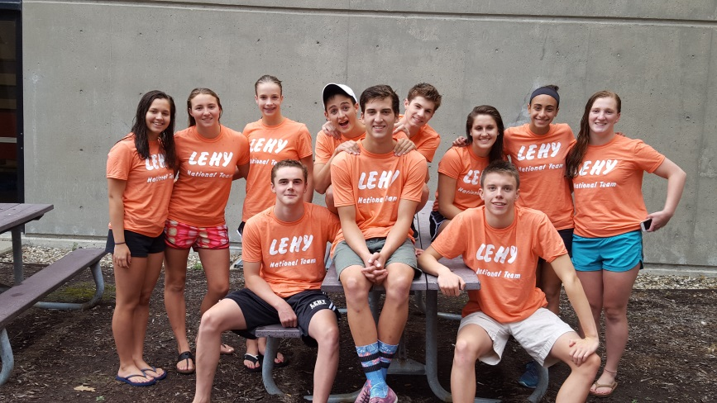

Quinn Packer
Good Morning. Both Robert and I are honored to be here today to share our
stories.
A year ago this was the last place I thought I would be. The sport I loved had
become a chore and I decided I was done swimming. I took last summer off and
had no intentions of swimming the short course season.
Swimming played a large role in who I was. Considering I swam every single
day, it was hard for it not to influence who I was as a person. LEHY was not the
first team I swam for. I had been on other teams but there was always
something missing and I wan not happy like I wanted to be. I never felt a true
team atmosphere on my previous teams and even when I was in relays I still felt
like each person was swimming for themselves. That was not what I wanted so I
felt like there was nothing left for me in swimming. I have given up, which is
something I rarely do. I did not see any other option besides quitting what I
thought was a burden.
Then in August of last summer, a few days after my friends came home from
Long Course YMCA Nationals, they asked me why I hadn’t been swimming all
summer. I simply said, “I quit.”
The first thing that came out of their mouths was, “Come to LEHY.”
They then proceeded to tell stories about their YMCA Nationals adventures and I
was honestly jealous. How could someone possibly have fun at a swim meet?
My question was quickly answered as they talked about the trip. Yes, the
swimming was fast and the races were intense, but I was hearing about
something more than just swimming. The stories contained the laughing and the
fun that I was a stranger to in the swimming world.
I called the senior coach of LEHY, Kaeley the next day. She spoke to me as a
person, not just an athlete, something I was not used to. She talked to me about
my issues with swimming and how I should just give LEHY a chance. It was the
first time in a long time I felt hopeful about getting back in the water. So,
needless to say, I gave LEHY a chance and it is a decision I will never regret.
Swimming is hard. I won’t deny that. It is the hardest thing I have ever done in
my life. With that said it is also the best. Although I am finishing my senior year
and moving on to new adventures, the lessons I have learned from swimming
and especially the past year with LEHY will carry me far in life.
Thank you to the coaches and to the friends who had my back when I needed it
most. Even more….thank you swimming. Thank you for the life lessons and
teaching me so much not only about life but about myself. I know now that
anything is possible as long as you don’t give up. Failure is okay as long as you
get back up and try again. That is what swimming taught me. I’m glad I am
going out of this sport on a high note. The Y has treated me like family. I have
never felt more accepted and valuable on a team and it is so comforting to know
my LEHY family will always be there for me. I now have my own stories from
YMCA Nationals. I now understand why my friends wanted me to become part
of the Y family.
Robert Adams-Michaud
Like Quinn, LEHY was not the first team I swam for. On my previous team I was
not the hardest worker, and I was just another swimmer. I didn't have relays,
there was no team atmosphere.
When I decided I needed to switch teams a few years ago, LEHY was my first
choice. I immediately felt like I was part of something bigger. I was no longer just
a swimmer, I was part of a team, even more, a family. A few months into my first
season with LEHY, my coach Kaeley said to me, "you know you're a pretty good
swimmer, you just need to get over being afraid of the pain."
I took that to heart and never looked back. The seniors took me under their wings
and I quickly became very close with them. I looked up to these boys, and they
pushed me to be my best. I had never felt a bond so strong, they were not just
teammates, they were brothers to me. While the 3 other swimmers on those
relays graduated, 3 more came in and we became just as close.
Without the Y, LEHY, my coach Kaeley, and my teammates. I never would've
had the experience of a real team, I never would've created the bonds I have. So
when Quinn was struggling I knew the answer. Turn to the family at LEHY, turn
to the family at the Y. I can't thank the people I've had the honor to share these
moments with enough. So when you're questioning whether or not you want to
continue swimming, asking is it worth it? Remember, pain is temporary, pride is
forever. And your Y family will be there to help you through it all.
As we enter the last day of competition at these 2015 Long Course YMCA
Nationals, hang in there and go out and race. Good luck.

