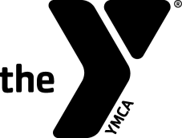
Swim Officials Administrative Swim Official Training Clinic

Hosted by:
Date & Time:
Site:
Registration Fee:
Contacts' Names To attend, please contact
And Phones:

Purpose: To certify new administrative swim officials and re-certify
existing administrative swim officials for the YMCA of the
USA's Competitive Swimming Program.
Prerequisites:
- Minimum Age: 21 years old.
- Associated with a recognized YMCA Swim Team.
- For re-certification, have worked at least 12 sessions as an Administrative Swim Official over the previous three-year certification period.

Registration Form
Name:_____________________ Telephone:____________________
Last 4 Digits of SSN:____________ Date of Birth:_________________
Your Address:____________________________________________
City:____________________ State:_______ Zip: _______________
Email Address: ___________________________________________
YMCA Name: _____________________________________________
YMCA Address: ___________________________________________
YMCA City, State, Zip: ______________________________________
YMCA Phone: _________________
YMCA Aquatics Director's or Coach’s Signature:____________________

