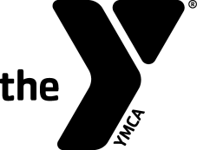
Swim Officials Level I Training Clinic

Hosted by:
Date & Time:
Site:
Registration Fee:
Contacts' Names To attend, please call:
And Phones:

Purpose: To certify new officials and re-certify existing officials for the YMCA of the USA's Competitive Swimming Program as Level I Officials. The clinic will prepare participants to act in the capacities of Stroke and Turn Judge, Relay Take-off Judge, Place Judge and Timer.
Prerequisites:
- Minimum Age: 21 years old.
- Associated with a recognized YMCA Swim Team.

Registration Form

Name:_____________________ Telephone:____________________
Last 4 Digits of SSN:____________ Date of Birth:_________________
Your Address:____________________________________________
City:____________________ State:_______ Zip: _______________
Email Address: ___________________________________________
YMCA Name: _____________________________________________
YMCA Address: ___________________________________________
YMCA City, State, Zip: ______________________________________
YMCA Phone: _________________
YMCA Executive Director's Signature:___________________________

