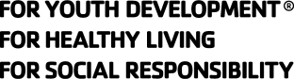
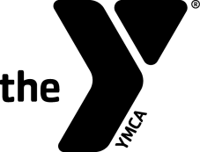
YMCA of the USA

Experienced Swim Officials Level II Recertification Clinic

Hosted by:

Date & Time:

Site:

Registration Fee:

Contacts' Names To attend, please contact:

And Phones:

Purpose: To re-certify senior officials for the YMCA of the USA's Competitive Swimming Program as Level II Officials. The clinic will discuss significant rules changes and issues facing the Referee, Starter and Chief Judge. (This clinic will may also serve to re-certify USA-S officials; check with your LSC.)

Prerequisites:
- Minimum Age: 21 years old.
- Associated with a recognized YMCA Swim Team.
- Have attended at least two previous Level II clinics and passed the related Level II tests
- Have worked at least 12 sessions on deck as a Level II Certified Official over the previous three-year certification period

Registration Form

Name:_____________________ Telephone:____________________

Last 4 Digits of SSN:____________ Date of Birth:_________________

Your Address:____________________________________________

City:____________________ State:_______ Zip: _______________

Email Address: ___________________________________________

YMCA Name: _____________________________________________

YMCA Address: ___________________________________________

YMCA City, State, Zip: ______________________________________

YMCA Phone: _________________

YMCA Executive Director's Signature:___________________________

