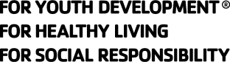
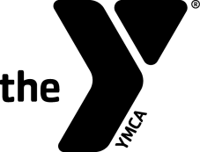
Swim Officials Level II Training Clinic

Hosted by:
Date & Time:
Site:
Registration Fee:
Contacts' Names To attend, please call:
And Phones:

Purpose: To certify new officials and re-certify existing officials for the YMCA of the USA's Competitive Swimming Program as Level II Officials. The clinic will prepare participants to act in the capacities of Referee, Starter and Chief Judge.
Prerequisites:
- Minimum Age: 21 years old.
- Associated with a recognized YMCA Swim Team.
- For new Level II officials, have been certified for at least 1 year as a YMCA Level I Official and worked at least 8 sessions on deck as a Level I Certified Official
- For re-certification, have worked at least 12 sessions on deck as a Level II Certified Official over the previous three-year certification period.

Registration Form
Name:_____________________ Telephone:____________________
Last 4 Digits of SSN:____________ Date of Birth:_________________
Your Address:____________________________________________
City:____________________ State:_______ Zip: _______________
Email Address: ___________________________________________
YMCA Name: _____________________________________________
YMCA Address: ___________________________________________
YMCA City, State, Zip: ______________________________________
YMCA Phone: _________________
YMCA Executive Director's Signature:___________________________

